

  - Construction phase: 2016 - 2024
November 2025
Air, Odour and Noise Sciences, Environmental Sciences Branch, Science Division

Analysis of West Gate Tunnel Project air monitoring data


Authorised and published by the Victorian Government, 1 Treasury Place, Melbourne
epa.vic.gov.au
Environment Protection Authority Victoria
GPO BOX 4395 Melbourne VIC 3001
1300 372 84
This content is for general information only. Obtain professional advice if you have any specific concern. EPA Victoria has made reasonable effort to ensure accuracy at the time of publication. Except where noted at epa.vic.gov.au/copyright, all content in this work* is licensed under the Creative Commons Attribution 4.0 Licence. To view a copy of this licence, visit creativecommons.org. EPA acknowledges Victoria’s First Nations peoples as the Traditional Owners of the land and water on which we live and work. We pay our respect to their Elders past and present.


Contents
1 Introduction 4
2 Monitoring stations 5
2.1 Air quality reference standards used for assessing air pollutant concentrations 7
3 Analysis of data 9
3.1 PM_{2.5} concentrations 9
3.2 PM₁₀ concentrations 12
3.3 Carbon monoxide nitrogen dioxide concentrations 15
4 Conclusion 16
5 References 21

Introduction
This report reviews the West Gate Tunnel Project (WGTP) air quality data collected between July 2016 and December 2024 which is during the tunnel project’s construction phase.
Environment Protection Authority Victoria (EPA) operates its own air monitoring stations across the state. This includes Melbourne’s inner west. The relevant inner west stations are in Footscray and Brooklyn. Each has been collecting air quality data over a long period.
The following air pollutants are measured at EPA stations (noting that not all were collected at every station, Table 1):
- particulate matter (PM_{2.5} - particulate matter less than 2.5 microns and PM₁₀ - particulate matter less than 10 microns)
- carbon monoxide (CO)
- nitrogen dioxide (NO₂).
These pollutants are common in urban areas. The major sources of these pollutants in Melbourne’s west are:
- emissions from motor vehicles
- domestic activities (for example smoke from wood heating)
- industry/commercial activities
- shipping
- diesel train movements.
The Inner West Air Quality Network (the Network) asked us to analyse air quality data from the WGTP stations. This included comparing the results to Melbourne air monitoring station data. The Network includes members from local councils and the community.
This is an update on 2 previous reports:
- EPA publication 2058 (2023) examined air quality data from the WGTP stations between July 2016 and December 2022
- Appendix D of Air Pollution in Melbourne’s Inner West (2020) analysed data between July 2016 and December 2019.
There are some minor differences in the reported air quality concentrations between the first report and the current one. This is due to revised statistical analysis. More recent EPA validation and updated measurement values identified minor differences in results. These revisions do not alter the conclusions of the previous report.
For consistency, the data presented in this report is what we will reference in further work.
We have assessed air quality concentrations at the 6 WGTP monitoring stations. These are in Brooklyn, Spotswood and Yarraville. The results have been compared to:
- general ambient concentrations recorded at EPA’s monitoring stations
- the relevant values in the Victorian Environment Reference Standard (ERS) (Victorian Government, 2021).
Monitoring around the WGTP will continue for either:
- a minimum of 5 years following the tunnel's opening
- a lesser period as agreed with EPA.
This will allow for ongoing assessment of air quality levels in the local area once vehicles are using the tunnel. The data can also be used to determine appropriate controls that could be implemented to further reduce air pollution.

Monitoring stations
The WGTP operates 6 air monitoring stations to assess air quality around the tunnel development. The location of each WGTP station is shown in Figure 1 along with EPA’s inner west air monitoring stations.
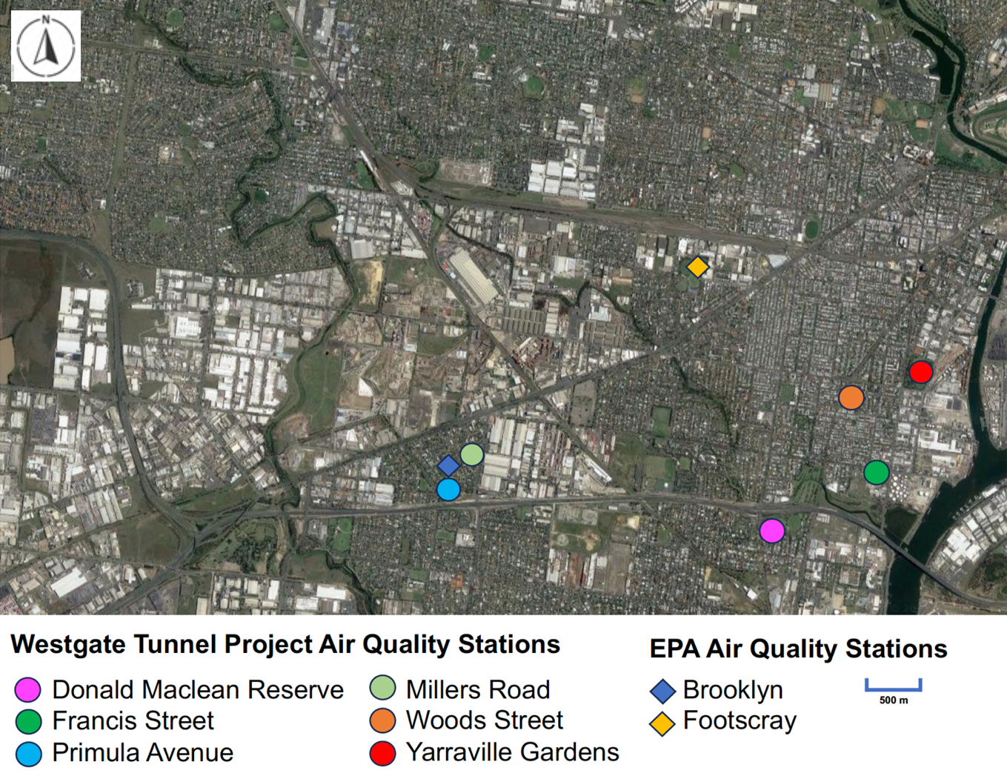
Figure 1: Location of WGTP and EPA (Brooklyn and Footscray) air monitoring stations. EPA’s Alphington and CBD stations are not shown.
Monitoring stations located near busy major roads:
- Francis Street (WGTP 2)
- Primula Avenue (WGTP 4)
- Donald McLean Reserve (WGTP 5)
- Millers Road (WGTP 6).
These roads experience more heavy-vehicle traffic compared to other major roads in Melbourne. These WGTP stations are classified as ‘roadside sites’. They are expected to have higher air quality concentrations due to vehicle emissions.
The monitoring station at Yarraville Gardens (WGTP 1) is not located near major roads. For this reason, it represents background air quality in the area. The Wood Street station (WGTP 3) is also considered a background site, as it is in a park about 40 metres from an elevated major road. The station is within a typical residential area with low vehicle traffic.
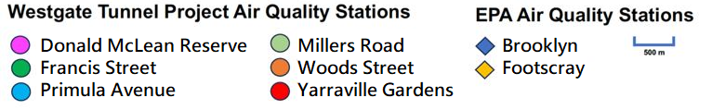
EPA’s Footsore air monitoring station represents general background air quality in the inner west. The Brooklyn monitoring station measures local air quality in the Brooklyn area. This includes local industrial and commercial activities.
Also included in this assessment are EPA monitoring stations (not shown in Figure 1). These represent background air quality near roads in the CBD. They are in:
- Alphington
- the inner north of the CBD.
All 10 stations used instruments that met the United States EPA Federal Register (part 53) for Ambient Air Monitoring Equivalent Methods (USEPA, 2023). This is the requirement for the with Australian/New Zealand Standard (AS/NZS).
An independent National Association of Testing Authorities (NATA) accredited laboratory monitored the 6 WGTP sites. We monitored our sites as EPA is NATA accredited for air quality analysis and measurement. We complied with AS/NZS air monitoring methods.
The air pollutants measured at each of the different stations are listed in Table 1.
- Air pollutants measured at each monitoring station
Monitoring station | Air pollutant
Yarraville Gardens (WGTP station 1) | PM_{2.5} | PM₁₀
Francis Street (WGTP station 2) | PM_{2.5} | PM₁₀
Woods Street (also known as Railway Reserve)  (WGTP station 3) | PM_{2.5} | PM₁₀
Primula Avenue (WGTP station 4) | PM_{2.5} | PM₁₀ | NO₂ | CO
Donald McLean Reserve (WGTP station 5) | PM_{2.5} | PM₁₀
Millers Road (WGTP station 6) | PM_{2.5} | PM₁₀
EPA network station, Alphington (EPA 1) | PM_{2.5} | PM₁₀ | NO₂ | CO
*EPA network station, Brooklyn (EPA 2) |  | PM₁₀
EPA network station, Melbourne CBD (CBD) (EPA 3) | PM_{2.5}
EPA network station, Footscray (EPA 4) | PM_{2.5} | PM₁₀ | NO₂ | CO

Air quality reference standards used for assessing air pollutant concentrations
The ERS (Victorian Government, 2021) defines the desired outcomes for human health and the environment in Victoria. It provides a range of reference points or benchmarks for each pollutant. These are used when reviewing the condition of air in the environment. Table 2 shows the ERS values for air pollutants: particulates (PM_{2.5} and PM₁₀), NO₂ and CO. We cite these when reporting environmental quality measures.
The ERS adopts the requirements of the National Protection Measure for Ambient Air Quality (AAQ NEPM) with some modifications. For example, the ERS has adopted a lower 1-year threshold of 20 µg/m³ for PM₁₀ compared to the AAQ NEPM (25 µg/m³). The AAQ NEPM threshold is proposed to be reduced to 20 µg/m³ in 2025.
This ERS is not a compliance standard. Its primary function is to provide an environmental assessment and reporting benchmark.
EPA has determined the pollutant ambient air objectives are not compliance standards (EPA publication 1992, 2021). They should not be considered levels one can pollute up to, or below (whereby further action is no longer required). This is because ERS listed air quality indicators such as PM_{2.5} and PM₁₀ are based on a combination of a:
- health risk assessment
- cost benefit analysis.
The ERS notes these do not define the risk-free level. They are benchmarks to help evaluate the level of risk posed by concentrations in ambient air.
Consequently, EPA uses the ERS objectives to:
- understand the level of risk to health
- determine whether there has been a change to that level of risk that might:
  - influence our advice to community
  - enable discussions with the WGTP group.

*The PM2.5 data from the EPA Brooklyn station is not used for comparison in this review because the method of PM2.5 measurement is derived from a ‘visibility’ measurement, which is not the same method of measurement as the other stations. The methods EPA use to monitor air quality is summarised on our website.
- Environment Reference Standard values for air pollutants in Victoria
Pollutant | Environment Reference Standard information
 | Averaging period | Concentration
PM_{2.5} | 1 day | 25 µg/m³
PM_{2.5} | 1 year | 8 µg/m³
PM₁₀ | 1 day | 50 µg/m³
PM₁₀ | 1 year | 20 µg/m³
NO₂ | Hourly | 80 ppb
NO₂ | 1 year | 15 ppb
CO | 8 hourly | 9 ppm
ppb = parts per billion
ppm = parts per million
µg/m³ = micrograms per cubic metre

Analysis of data
The following sections provide a summary for each of the 4 air pollutants measured across all 10 stations, benchmarked against the ERS.

PM_{2.5} concentrations
The average daily concentrations of PM_{2.5} are shown below in Figures 2 and 3. Figure 2 shows the entire data set, while Figure 3 displays the same period without January 2020. This month was severely affected by bushfire smoke concentrations greater than 100 µg/m³. Removing that data makes the relevant concentrations viewable in greater detail.
Table 3 presents a summary of:
- the maximum PM_{2.5} concentration for one day
- the number of times concentrations were higher than the ERS (one-day maximum: 25 µg/m³)
- the annual maximum value.
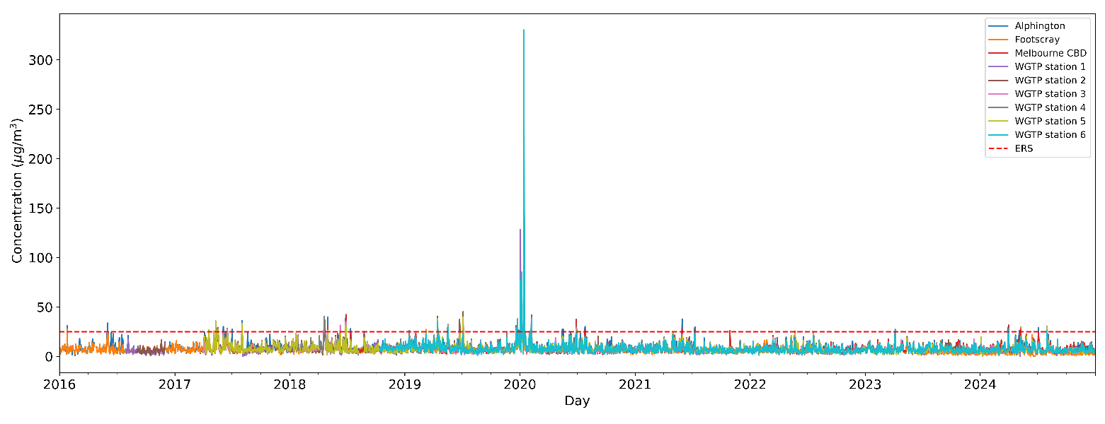
Figure 2: Daily averaged PM_{2.5} concentrations measured between July 2016 and December 2024 at all WGTP and EPA stations. The red line shows the ERS one day concentration (25 µg/m³).
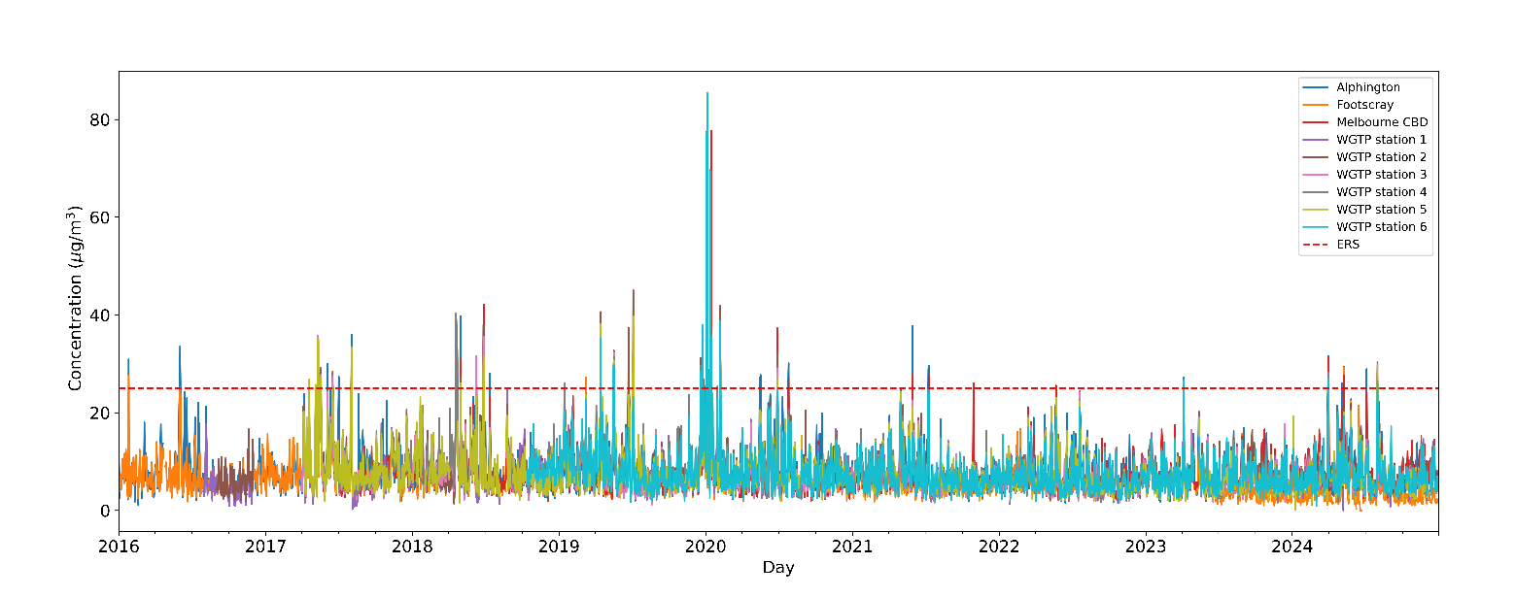
Figure 3: As per Figure 2 but with concentrations in January 2020 greater than 100 µg/m³ (from bushfire smoke) removed so other concentrations can be viewed in detail. The red line shows the ERS one-day concentration (25 µg/m³).
The data shows all 9 stations reported similar one-day average concentrations of PM_{2.5} air pollution (Figure 4).
Assessment of the data shows concentrations were higher than the ERS PM_{2.5} one-day value of 25 µg/m³ on at least one occasion per year between 2017 and 2020. The maximum number of days this value was exceeded was 13 in 2020. PM_{2.5} daily concentrations were lower than the one-day ERS of 25 µg/m³ standard 96.4% of the time over this period.
Table 3 also shows that PM_{2.5} daily concentrations were lower than the one-day ERS of 25 µg/m³ standard:
- 99.2% of days in 2021
- 99.7% of days in 2022
- 99.7% of days in 2023
- 98.3% of days in 2024.

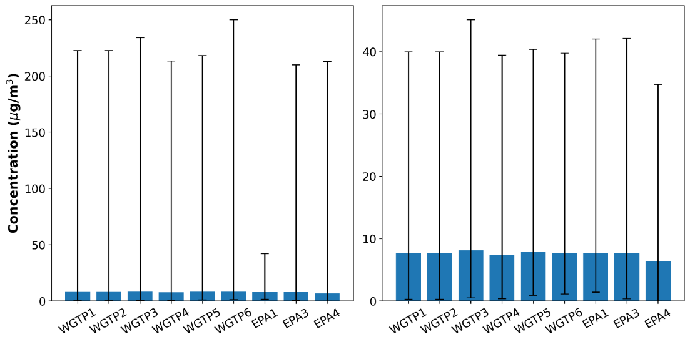
Figure 4: Average daily PM_{2.5} concentrations over the 7.5-year data period.
The vertical lines show the range of values (minimum and maximum) over the data period.
Left panel: average daily PM_{2.5} concentrations measured from 2016-2024 at WGTP and EPA stations.
Right panel: average daily PM_{2.5} concentrations measured from 2016-2024 (year 2020 excluded due to extremes from bushfires) at the WGTP and EPA stations.
Between 2017 and 2020 most stations reported one-year average concentrations of PM_{2.5} above the corresponding ERS value of 8 µg/m³ (Table 3). In 2019 and 2020, PM_{2.5} air quality measures at WGTP stations were slightly higher than EPA stations (Table 3). Concentrations at all stations were below the one-year average value of 8 µg/m³ in 2021, 2022 and 2023 (Table 3). In 2024, all stations (except for EPA3, CBD, which reported one-year average value of 8.3 µg/m³) also reported one-year average value below the ERS.
Local weather and pollution sources influenced the readings at each monitoring station. These varied over the 7.5-year period.
The data shows that peak PM_{2.5} concentrations occurred during autumn and winter (Figure 2 and 3). This excludes the period between late 2019 and early 2020, which was impacted by high concentrations of bushfire smoke. Calm autumn and winter weather limiting the dispersal of local pollution was the biggest factor that reduced air quality. In 2021, reduced vehicle traffic due to the COVID-19 restrictions contributed to lower concentrations of PM_{2.5}. In 2022, the wet weather associated with the La Niña event helped to reduce atmospheric concentrations of PM_{2.5}.
Pollutant levels recorded in 2023 were similar to those in 2022. However, in 2024 all sites seem to have been affected by elevated concentrations more likely due to bushfires. As it was noted in the previous report, these influencing factors can change, and some variation is expected.

PM₁₀ concentrations
The average daily concentrations of PM₁₀ for all stations are shown in Figure 5. The ERS for PM₁₀ (daily average, 50 µg/m³) is also shown. Table 3 shows:
- summary data for the number of times concentrations were higher than the ERS maximum one-day value (50 µg/m³)
- the annual maximum value for each station.
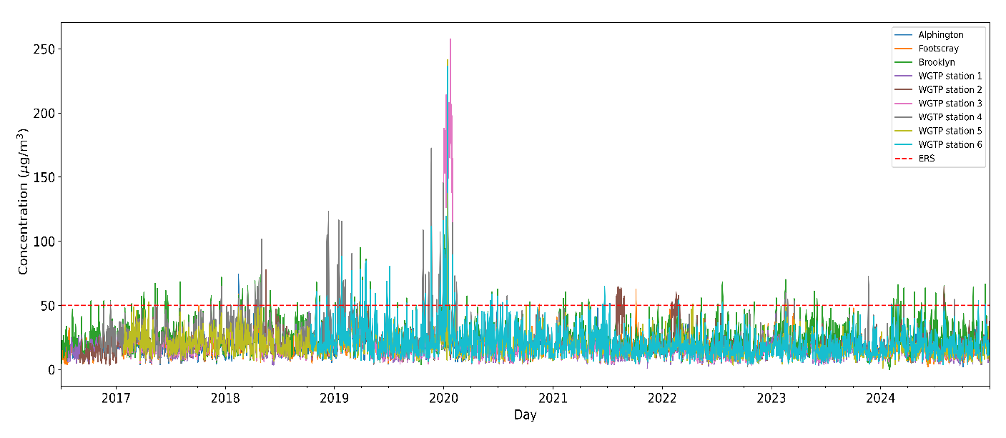
Figure 5: Daily averaged PM₁₀ concentrations between July 2016 and December 2024. Data from all operating WGTP and EPA stations is included. The red line represents the one -day PM10 ERS.
Over the 7.5-year data period, there were numerous days each year where concentrations were higher than the ERS one-day value on at least one occasion. The maximum number of exceeding days was 46 in 2020 (Figure 5,Table 3).
The highest concentrations of PM₁₀ occurred in January 2020. This was due to bushfire smoke which resulted in multiple days where concentrations were higher than the one-day ERS (50 µg/m³).
PM₁₀ concentrations were below the ERS one-day value (50 µg/m³), 87.4% of the time between 2016 and 2020.
The frequency of daily PM₁₀ concentrations being greater than 50 µg/m³ has reduced over time. Over 98% of days in 2021 and 2023 were lower than the ERS. However, the number of days with daily PM₁₀ lower than the ERS decreased to 95.6% in 2023. This was due emissions associated with the Brooklyn site that recorded 15 days with daily PM₁₀ higher than the ERS.
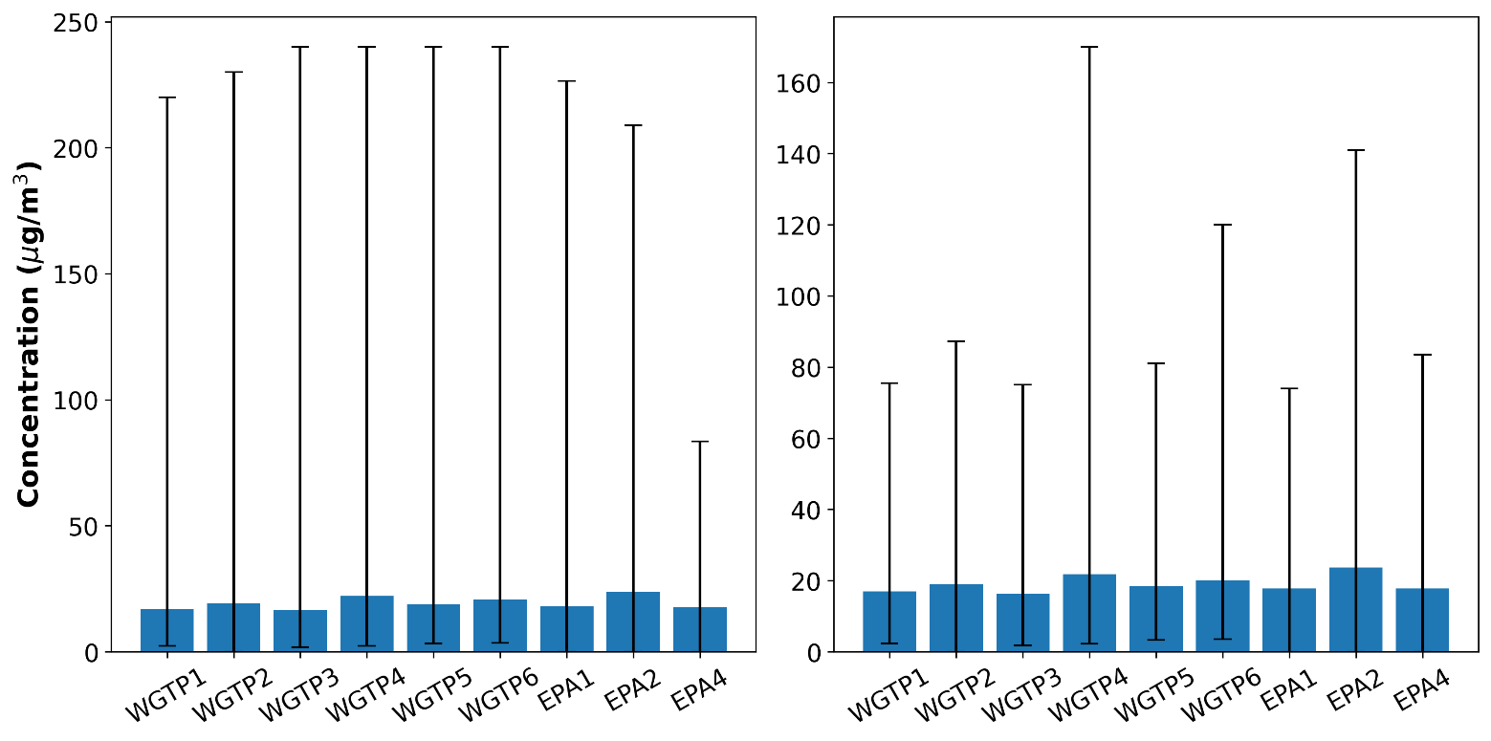
Figure 6: Average daily PM₁₀ concentrations over the 7.5-year data period. The vertical lines show the range of values (minimum and maximum) over the data period.
Left panel: average daily PM₁₀ concentrations measured during 2016-2024 at the WGTP and EPA stations.
Right panel: average daily PM₁₀ concentrations measured during 2016-2024 (year 2020 excluded due to extremes from bushfires) at the WGTP and EPA stations.
The one-year average concentrations were variable. The WGTP and EPA2 (Brooklyn) stations recorded results higher than the ERS (20 µg/m³) between 2016 and 2020 (Table 3). WGTP4 reported higher concentrations than the EPA station at Brooklyn (EPA2) between 2016 and 2020. Concentrations fell below the standard at all stations during 2021-2024 except at the EPA Brooklyn station. This station shows an increase in concentrations. Overall, the full year data from 2017-2024 shows a reduction in one-year PM₁₀ concentration (0, Table 3).
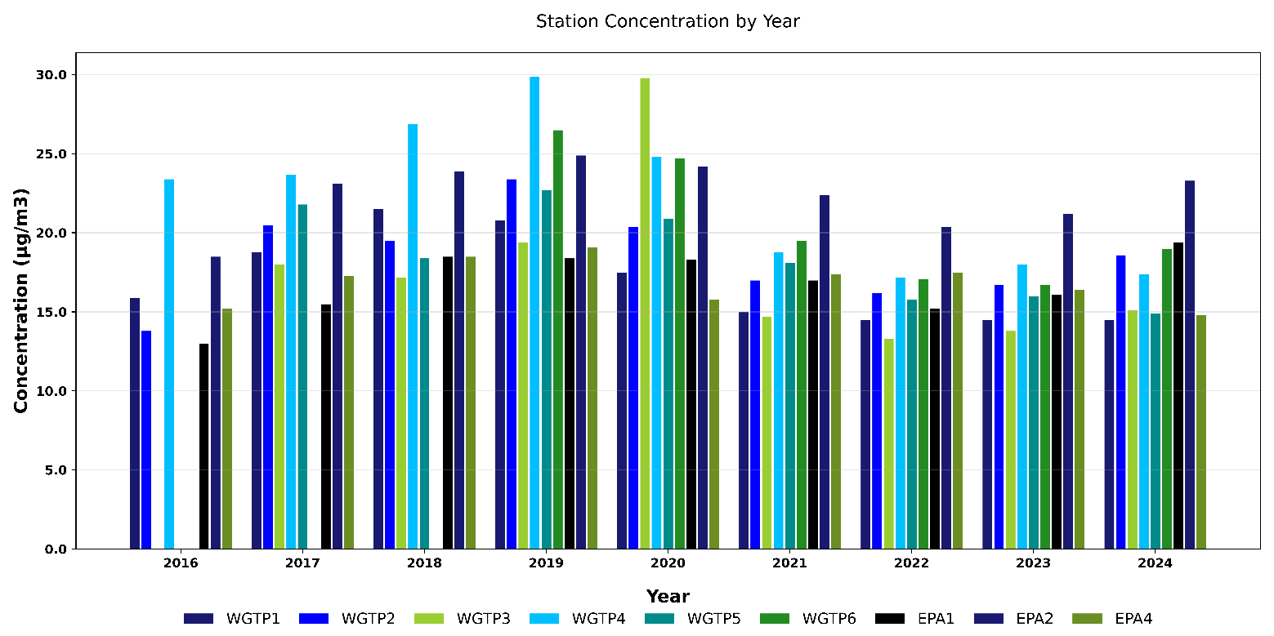
Figure 7: PM₁₀ concentrations (one -year average) across monitoring period 2016 – 2024.
Measured PM₁₀ concentrations are affected by factors which transport and disperse pollutants. These include:
- variations in local pollution sources
- weather conditions.
PM₁₀ concentrations were found to be higher than PM_{2.5} concentrations during late spring and summer. There is typically less rain to flush particles from the atmosphere during this period. This suggests that the main source of PM₁₀ during this period is remobilised dust.
COVID-19 travel restrictions in 2021 contributed to lower concentrations of PM₁₀. In 2022, the wet weather associated with La Niña event helped to reduced atmospheric concentrations of PM₁₀. PM₁₀ concentrations recorded in 2023 were similar to those in 2022. In 2024, there was a slight increase in concentrations especially for EPA Brooklyn site most likely due to local factors. These influencing factors can change, and some variation is expected going forward.
The EPA Brooklyn station (EPA 2) measures dust sources associated with the Brooklyn Industrial Precinct. This is home to more than 60 businesses including recycling sites, abattoirs, tallow producers and landfills (EPA, 2020).
Over the study period it is evident this location has persistent PM₁₀ issues and remains a focus for EPA action. We are mitigating the risks associated with PM₁₀ dust production at the Precinct. Currently this includes dispatching a warning email to residents and industry. The email advises recipients to take appropriate action to reduce dust production and impacts. For example, advice to industry operating at the Brooklyn Industrial Precinct includes:
- the use of water carts
- the use of sprinklers
- the use of street sweepers
- limiting dust producing activities.
When the Brooklyn Industrial Precinct (EPA2) was removed, between 2017 and 2020:
- similar one-day average concentrations of PM₁₀ air quality were recorded across all stations (Figure 5)
- the one-year average concentrations are slightly higher at WGTP stations compared to EPA stations (EPA1, EPA4).
Assessment of the annual data between 2017 and 2024 shows an increase in the number of days where air quality is better than the ERS PM₁₀ one-day value. Annual average concentrations for a majority of WGTP stations also decreased 2021 and 2024

Carbon monoxide nitrogen dioxide concentrations
The Project only measures carbon monoxide (CO) and nitrogen dioxide (NO₂) concentrations at the WGTP 4 station. EPA measures the same air pollutants at its Alphington (EPA 1) and Footscray (EPA 4) stations (Table 1).
Figure 8 shows the 8-hr average CO concentrations plotted against the corresponding ERS 8-hour value of 9 ppm (parts per million). There is no one-year ERS for CO.
At no time during the data period were any concentrations greater than the ERS. The maximum recorded value was 2.2 ppm, recorded in 2020 at the Footscray EPA 4 station.
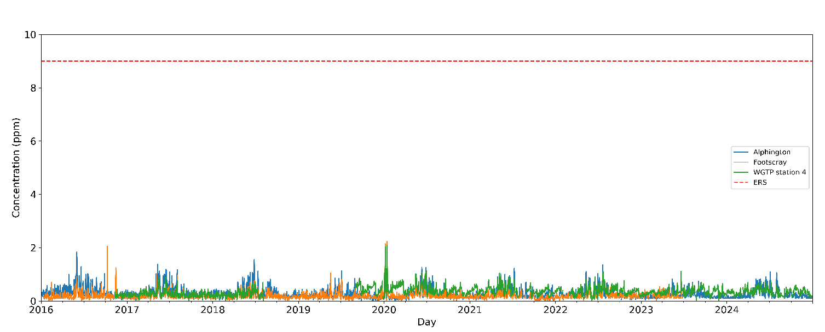
Figure 8: 8-hourly averaged CO concentrations measured at EPA stations (Alphington and Footscray) and WGTP 4.
The red line represents the 8-hour ERS for CO.
Note: in 2017, CO data is available from 05 January to 31 December at WGTP4.
Assessment of NO₂ concentrations is benchmarked against the ERS values for one-hour at 80 ppb (parts per billion) and a one-year value at 15 ppb. The maximum one-hour concentrations for each day and station are shown in Figure 9 and are compared to the one-hour ERS value for NO₂.
The average of the annual maximum concentrations measured at all three NO₂ monitored stations over the 7.5-year data period was 10.9 ppb. The WGTP 4 station recorded values higher than the ERS in 2016, 2017 and 2018 (Table 3). Note that for 2023 and 2024, there was no measurement data for EPA Footscray site due to station relocation.
The WGTP 4 station was the only station to record concentrations higher than the NO₂ one-hour average ERS in 2022. The higher NO₂ concentrations at the WGTP 4 station are likely to it being located near a major road.
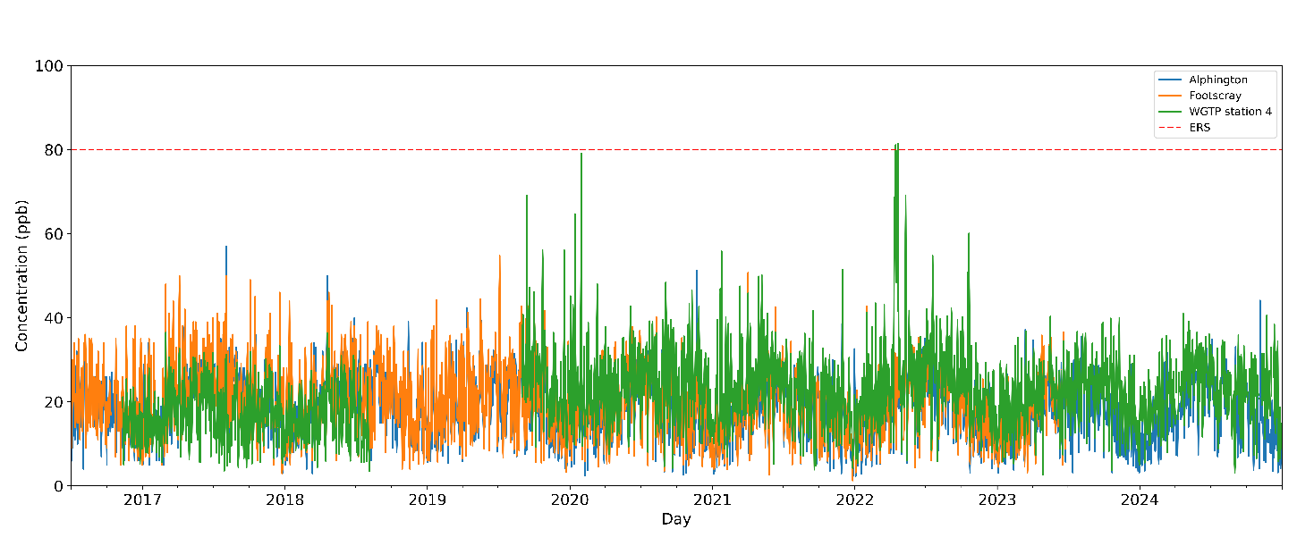
Figure 9: Maximum daily one-hour NO₂ concentrations measured at EPA stations (Alphington and Footscray) and
WGTP 4.
Note: in 2016 NO₂ data is available only from 3 November to 31 December at WGTP4.

Conclusion
The data shows the highest concentrations of air pollution were associated with PM_{2.5} and PM₁₀. Concentrations varied over the years across all stations. This was due to a range of local air pollution sources and weather conditions.
- Average daily PM_{2.5} concentrations were below the one-day ERS 96.4% of days between 2017 and 2020. This increased to over 99% of days during 2021-2023. It decreased to 98.3% in 2024.
- Between 2017 and 2020, every station (except WGTP6 in 2018) recorded a one-day PM_{2.5} concentration above the ERS at least once.
- Average annual PM_{2.5} concentrations at WGTP stations were above EPA stations in 2019 and 2020.
- All stations reported average one-year PM_{2.5} concentrations below the ERS in 2021-2023. EPA Brooklyn site was the only station that reported average one-year PM₁₀ concentrations above the ERS in 2024.
- Average daily PM₁₀ concentrations were below the one-day ERS 87.2% of the time between 2017 and 2020. They increased to over 98% of days between 2021 and 2023 and decreased to 95.6% in 2024.
- The PM₁₀ one-year average concentrations were variable. Findings were higher than the ERS each year at one EPA site (EPA 2) but not at the other EPA sites.
- PM₁₀ concentrations varied across WGTP stations. Concentrations were higher than ERS for one to 4 years, depending on the station, between 2017-2020.
- All WGTP stations reported average one-year PM₁₀ concentrations below the ERS in 2021- 2024.
Lower concentrations in particulate matter in 2021 and 2022 were influenced by:
- reductions in traffic during COVID-19 pandemic
- fewer bushfires
- wet weather associated with a La Niña event (2022).
The majority of sites also recorded lower particulate matter concentrations in 2023. The exception is EPA’s Brooklyn station. The increase in particulate matter concentrations at this site is likely influenced by local sources.
All of these factors can change, and some variation is expected going forward.
CO concentrations were not recorded at concentrations greater than those set in the ERS. WGTP station 4 recorded concentrations higher than the NO₂ one-year ERS in 2017 and 2018 and for the one-hour ERS in 2022. There have been no NO₂ one-hour concentrations recorded above the ERS in 2023 and 2024.
The air quality showed similar pollutant concentrations over the data period. Particulate pollution sources were primarily:
- local industrial and commercial activities
- road-source emissions
- smoke from domestic sources (for example, wood heating) and bushfires during late 2019 and early 2020.
The higher NO₂ concentrations at the WGTP locations are likely to be due to road source emissions.
Elevated concentrations of air pollution typically arise due to calm weather. These conditions don’t disperse pollutants, allowing for increased local concentrations. Exposure to air pollution can be associated with poorer health outcomes. Sensitive people are the most likely to be impacted. It is necessary to reduce all sources where possible to prevent potential harm to people and the environment. The first step in prevention is to understand the sources of pollution in detail.
We conducted a study between 2021 and 2022 to better understand sources of PM_{2.5} pollution in Melbourne’s inner west. The findings were published in 2024 (EPA Publication 2060, 2024). They help to inform measures to better manage pollution at their source.
EPA’s Western Metropolitan Region is also working to reduce industrial air pollution in Melbourne’s inner west. Where possible we hope it will be prevented altogether. This is being achieved through our proactive regulatory approach. We are using the Environment Protection Act 2017, new guidelines, and tools across the regulatory cycle. This includes education and awareness supported by compliance and enforcement.
We target higher-risk areas and activities. This includes businesses and stations in the Brooklyn Industrial Precinct. Contact the Brooklyn Community Representative Group (Brooklyn Industrial Precinct, 2023) for information about our:
- work
- actions
- outcomes.
We are committed to the Victorian Air Quality Strategy (Victorian Government, 2022). We are working with the Department of Energy, Environment and Climate Action and other government departments to implement it.
The Strategy is focused on tackling major pollution. It includes a $2.84 million commitment to establish Air Quality Improvement Precincts to address local air quality issues. These will be in Melbourne’s inner and outer west (Sustainability Victoria, 2023).

- Summary of pollutant averaged concentrations for the WGTP (data supplied by West Gate Tunnel Project) and EPA stations assessed in this report.
Monitoring results are collected every 5 minutes, and the averaging period is:
- one-day max value refers to the maximum one-day (24 hour) concentration recorded at each station during the relevant year.
- 1 year refers to the average concentration at each station during the relevant year.
- one-hour max value refers to the maximum one-hour concentration recorded at each station during the relevant year.
- 8-hour max value is the maximum concentration recorded at each station during the relevant year.
- The “(above ERS)” refers to the numbers of days or hours when air quality measures were reported above the ERS value at that station in any given year, presented in brackets beside the pollutant concentration.
Note, air quality measurements commenced mid 2016 with different stations coming online according to their respective installation and operation date.
Year | Pollutant | Averaging period | ERS | WGTP1 | WGTP2 | WGTP3 | WGTP4 | WGTP5 | WGTP6 | EPA1 | EPA2 | EPA3 | EPA4
2016 | PM_{2.5} | 1 day max (above ERS) | 25 µg/m³ | 17.6 | 16.6 |  |  |  |  | 21.3 |  |  | 17.7
2016 | PM_{2.5} | 1 year | 8 µg/m³ | 5.2 | 5.8 |  |  |  |  | 6.5 |  |  | 6.3
2016 | PM₁₀ | 1 day max (above ERS) | 50 µg/m³ | 43.8 | 29.9 |  | 53.2 (1) |  |  | 34.3 | 53.8 (3) |  | 38.8
2016 | PM₁₀ | 1 year | 20 µg/m³ | 15.9 | 13.8 |  | 23.4 |  |  | 13 | 18.5 |  | 15.2
2016 | NO₂ | 1 day max (above ERS) | 80 ppb |  |  |  | 25.5 |  |  | 34 |  |  | 38
2016 | NO₂ | 1 year | 15 ppb |  |  |  | 15.3 |  |  | 8.1 |  |  | 9.2
2016 | CO | 8 hour max (above ERS) | 9 ppm |  |  |  | 0.4 |  |  | 1 |  |  | 2
2017 | PM_{2.5} | 1 day max (above ERS) | 25 µg/m³ | 31.6 (6) | 32.8 (7) | 35.8 (7) | 33.5 (3) | 35.4 (8) |  | 35.9 (8) |  | 28.7 (3) | 34.8 (4)
2017 | PM_{2.5} | 1 year | 8 µg/m³ | 8.8 | 9.2 | 9 | 8.8 | 9.4 |  | 9.3 |  | 8.5 | 7.9
2017 | PM₁₀ | 1 day max (above ERS) | 50 µg/m³ | 43.4 | 51.7 (1) | 40.6 | 65.0 (6) | 52.6 (1) |  | 41.1 | 71.7 (16) |  | 49.8
2017 | PM₁₀ | 1 year | 20 µg/m³ | 18.8 | 20.5 | 18 | 23.7 | 21.8 |  | 15.5 | 23.1 |  | 17.3
2017 | NO₂ | 1 day max (above ERS) | 80 ppb |  |  |  | 36.5 |  |  | 57 |  |  | 50
2017 | NO₂ | 1 year | 15 ppb |  |  |  | 17.4 |  |  | 9.7 |  |  | 11.5
2017 | CO | 8 hour max (above ERS) | 9 ppm |  |  |  | 0.9 |  |  | 1.4 |  |  | 0.9
2018 | PM_{2.5} | 1 day max (above ERS) | 25 µg/m³ | 40.0 (9) | 39.0 (8) | 39.5 (7) | 40.4 (7) | 31.6 (3) | 17.8 | 42.0 (8) |  | 42.1 (7) | 31.2 (5)
2018 | PM_{2.5} | 1 year | 8 µg/m³ | 8.7 | 8 | 7.1 | 7.8 | 7.2 |  | 8.5 |  | 8.5 | 7.8
2018 | PM₁₀ | 1 day max (above ERS) | 50 µg/m³ | 53.8 (1) | 77.5 | 49.2 | 123.2 (19) | 48.1 | 60.7 (3) | 74.0 (3) | 99.2 (17) |  | 58.8 (1)
2018 | PM₁₀ | 1 year | 20 µg/m³ | 21.5 | 19.5 | 17.2 | 26.9 | 18.4 |  | 18.5 | 23.9 |  | 18.5
2018 | NO₂ | 1 day max (above ERS) | 80 ppb |  |  |  | 36.4 |  |  | 50 |  |  | 46
2018 | NO₂ | 1 year | 15 ppb |  |  |  | 16.2 |  |  | 9.6 |  |  | 10.3
2018 | CO | 8 hour max (above ERS) | 9 ppm |  |  |  | 0.7 |  |  | 1.6 |  |  | 0.8
2019 | PM_{2.5} | 1 day max (above ERS) | 25 µg/m³ | 37.2 (7) | 45.1 (8) | 33.4 (5) | 38.7 (7) | 39.7 (6) | 38.0 (5) | 30.6 (2) |  | 28.6 (2) | 29.6 (4)
2019 | PM_{2.5} | 1 year | 8 µg/m³ | 9.3 | 9.7 | 8 | 10.1 | 9.1 | 9.1 | 7.8 |  | 7.6 | 7.6
2019 | PM₁₀ | 1 day max (above ERS) | 50 µg/m³ | 75.5 (14) | 87.3 (17) | 75.0 (8) | 170 (46) | 81.0 (15) | 120 (27) | 69.8 (6) | 141 (3) |  | 83.5 (8)
2019 | PM₁₀ | 1 year | 20 µg/m³ | 20.8 | 23.4 | 19.4 | 29.9 | 22.7 | 26.5 | 18.4 | 24.9 |  | 19.1
2019 | NO₂ | 1 day max (above ERS) | 80 ppb |  |  |  | 69 |  |  | 42.4 |  |  | 54.8
2019 | NO₂ | 1 year | 15 ppb |  |  |  | 14.1 |  |  | 9 |  |  | 10.4
2019 | CO | 8 hour max (above ERS) | 9 ppm |  |  |  | 0.9 |  |  | 1.1 |  |  | 1.1
2020 | PM_{2.5} | 1 day max (above ERS) | 25 µg/m³ | 223 (11) | 234 (13) | 213 (10) | 218 (11) | 250 (9) | 330 (10) | 214 (8) |  | 210 (11) | 213 (9)
2020 | PM_{2.5} | 1 year | 8 µg/m³ | 9.8 | 10 | 9.3 | 10 | 9.9 | 9.5 | 8.5 |  | 8.9 | 8.6
2020 | PM₁₀ | 1 day max (above ERS) | 50 µg/m³ | 2020 (8) | 230 (9) | 240 (7) | 240 (15) | 240 (9) | 240 (14) | 226 (7) | 209 (19) |  | 225 (6)
2020 | PM₁₀ | 1 year | 20 µg/m³ | 17.5 | 20.4 | 29.8 | 24.8 | 20.9 | 24.7 | 18.3 | 24.2 |  | 15.8
2020 | NO₂ | 1 day max (above ERS) | 80 ppb |  |  |  | 79.1 |  |  | 51.5 |  |  | 64.8
2020 | NO₂ | 1 year | 15 ppb |  |  |  | 13.9 |  |  | 8.2 |  |  | 9.8
2020 | CO | 8 hour max (above ERS) | 9 ppm |  |  |  | 2.1 |  |  | 2 |  |  | 2.2
2021 | PM_{2.5} | 1 day max (above ERS) | 25 µg/m³ | 24.1 | 25.3 (1) | 22.5 | 24.5 | 24.3 | 24.7 | 37.8 (3) |  | 27.8 (3) | 21.5
2021 | PM_{2.5} | 1 year | 8 µg/m³ | 7.4 | 7.5 | 6.9 | 7.7 | 7.5 | 7.3 | 7.4 |  | 6.9 | 5.7
2021 | PM₁₀ | 1 day max (above ERS) | 50 µg/m³ | 36 | 45 | 39 | 48 | 51.0 (1) | 64.0 (2) | 51.6 (1) | 60.4 (6) |  | 62.4 (1)
2021 | PM₁₀ | 1 year | 20 µg/m³ | 15 | 17 | 14.7 | 18.8 | 18.1 | 19.5 | 17 | 22.4 |  | 17.4
2021 | NO₂ | 1 day max (above ERS) | 80 ppb |  |  |  | 55.8 |  |  | 41.4 |  |  | 50.7
2021 | NO₂ | 1 year | 15 ppb |  |  |  | 12.6 |  |  | 7.8 |  |  | 8.8
2021 | CO | 8 hour max (above ERS) | 9 ppm |  |  |  | 1 |  |  | 1.2 |  |  | 0.7
2022 | PM_{2.5} | 1 day max (above ERS) | 25 µg/m³ | 24.4 | 21.3 | 24 | 22.7 | 23.1 | 21 | 23.2 |  | 25.5 (1) | 23.7
2022 | PM_{2.5} | 1 year | 8 µg/m³ | 7 | 7 | 6.5 | 6.8 | 7 | 6.5 | 7.4 |  | 7.6 | 6.3
2022 | PM₁₀ | 1 day max (above ERS) | 50 µg/m³ | 36 | 44 | 36 | 45 | 51.0 (1) | 54.0 (2) | 43.2 | 68.2 (6) |  | 56.2 (1)
2022 | PM₁₀ | 1 year | 20 µg/m³ | 14.5 | 16.2 | 13.3 | 17.2 | 15.8 | 17.1 | 15.2 | 20.4 |  | 17.5
2022 | NO₂ | 1 day max (above ERS) | 80 ppb |  |  |  | 81.5 (2) |  |  | 38.3 |  |  | 43.2
2022 | NO₂ | 1 year | 15 ppb |  |  |  | 14.1 |  |  | 8.6 |  |  | 9.5
2022 | CO | 8 hour max (above ERS) | 9 ppm |  |  |  | 1.1 |  |  | 1.4 |  |  | 0.7
2023 | PM_{2.5} | 1 day max (above ERS) | 25 µg/m³ | 21.2 | 23.5 | 22 | 20.6 | 21.7 | 24.6 | 27.2 (1) |  | 26.2 (1) | 22.8
2023 | PM_{2.5} | 1 year | 8 µg/m³ | 6.9 | 7.5 | 6.4 | 6.6 | 6.5 | 7 | 6.5 |  | 7.3
2023 | PM₁₀ | 1 day max (above ERS) | 50 µg/m³ | 45 | 37 | 33 | 74 (5) | 51 (1) | 45 | 43 | 70 (6) |  | 47.7
2023 | PM₁₀ | 1 year | 20 µg/m³ | 14.5 | 16.7 | 13.8 | 18 | 16 | 16.7 | 16.1 | 21.2 |  | 16.4
2023 | NO₂ | 1 day max (above ERS) | 80 ppb |  |  |  | 40.3 |  |  | 36.6 |  |  | 37.2
2023 | NO₂ | 1 year | 15 ppb |  |  |  | 11.6 |  |  | 7.8
2023 | CO | 8 hour max (above ERS) | 9 ppm |  |  |  | 0.2 |  |  | 0.3
2024 | PM_{2.5} | 1 day max (above ERS) | 25 µg/m³ | 37.3 (2) | 31.3 (2) | 31 (2) | 30.2 (1) | 32.7 (2) | 27.1 (1) | 31.6 (6) |  | 31.4 (4) | 29.2 (4)
2024 | PM_{2.5} | 1 year | 8 µg/m³ | 7.2 | 7.7 | 7.1 | 7 | 7 | 7.1 | 7.9 |  | 8.3
2024 | PM₁₀ | 1 day max (above ERS) | 50 µg/m³ | 40 | 65 (1) | 43 | 55 (2) | 39 | 54 (3) | 48 | 66.5 (15) |  | 44.1
2024 | PM₁₀ | 1 year | 20 µg/m³ | 14.5 | 18.6 | 15.1 | 17.4 | 14.9 | 19 | 19.4 | 23.3 |  | 14.8
2024 | NO₂ | 1 day max (above ERS) | 80 ppb |  |  |  | 39.6 |  |  | 44.1
2024 | NO₂ | 1 year | 15 ppb |  |  |  | 11.3 |  |  | 8.2
2024 | CO | 8 hour max (above ERS) | 9 ppm |  |  |  | 0.3 |  |  | 0.2

References
EPA (2024). Air pollution sources in inner west Melbourne. EPA Publication 2060, Environment Protection Authority Victoria, Australia. Available at: https://www.epa.vic.gov.au/about-epa/publications/2060-air-pollution-inner-west-melbourne
Brooklyn Industrial Precinct (2023). Brooklyn Community Representative Group, Brooklyn website, accessed 27 September 2023. Available at: http://www.brooklynip.com.au/bcrg-community-forum/ (accessed 2 October 2023).
EPA (2020). Air quality issues near the Brooklyn Industrial Precinct, EPA website, accessed 27 September 2023. Available at: https://www.epa.vic.gov.au/for-community/current-projects-issues/preventing-pollution-brooklyn (accessed 2 October 2023).
EPA (2021). Guide to the Environment Reference Standard. EPA publication 1992, Environment Protection Authority Victoria, Australia. Available at: https://www.epa.vic.gov.au/about-epa/publications/1992 (accessed 2 October 2023).
EPA (2023). Analysis of West Gate Tunnel Project air monitoring data. EPA Publication 2058, Environment Protection Authority, Australia. Available at https://www.epa.vic.gov.au/about-epa/publications/2058-west-gate-tunnel-project-air-monitoring-data-analysis (accessed 25 February 2025).
Inner West Air Quality Community Reference Group (2020). Air Pollution in Melbourne’s Inner West. Report. March 2020. Available at: https://www.environment.vic.gov.au/__data/assets/pdf_file/0029/486506/IWAQCRGReportFINAL.pdf (accessed 2 October 2023).
Sustainability Victoria (2023). Air Quality Improvement Precincts Grant Program. Available at: https://www.sustainability.vic.gov.au/grants-funding-and-investment/grants-and-funding/air-quality-improvement-precincts-grant-program (accessed 2 October 2023).
US EPA (2023). Ambient Air Monitoring Equivalent and Equivalent Methods; Designation of One New Equivalent Method. 88 FR 42718. Available at: https://www.federalregister.gov/documents/2023/07/03/2023-14083/ambient-air-monitoring-equivalent-and-equivalent-methods-designation-of-one-new-equivalent-method (accessed 2 October 2023).
Victoria Government (2021). Environment Reference Standard. Victoria Government Gazette No. S245, 26 May 2021. Melbourne. Victoria. Australia. Available at: https://www.gazette.vic.gov.au/gazette/Gazettes2021/GG2021S245.pdf (accessed 2 October 2023).
Victorian Government (2022). Clean air for all Victorians. Victoria’s Air Quality Strategy. Available at: https://www.environment.vic.gov.au/__data/assets/pdf_file/0032/603977/Victorias-air-quality-strategy.pdf (accessed 2 October 2023).

Accessibility
Contact us if you need this information in an accessible format such as large print or audio.
Please telephone 1300 372 842 or email contact@epa.vic.gov.au
Interpreter assistance

If you need interpreter assistance or want this document translated, please call 131 450 and advise your preferred language. If you are deaf, or have a hearing or speech impairment, contact us through the National Relay Service.



epa.vic.gov.au
Environment Protection Authority Victoria
GPO BOX 4395 Melbourne VIC 3001
1300 372 842

Authorised and published by the Victorian Government, 1 Treasury Place, Melbourne

