

This is version IWRG816.3 of the guide and replaces IWRG816.2 published April 2018.
July 2025
Permissioning Permitting Unit

Guide for waste transport vehicles – tanker vehicles and trailers


Authorised and published by the Victorian Government, 1 Treasury Place, Melbourne
epa.vic.gov.au
Environment Protection Authority Victoria
GPO BOX 4395 Melbourne VIC 3001
1300 372 84
This content is for general information only. Obtain professional advice if you have any specific concern. EPA Victoria has made reasonable effort to ensure accuracy at the time of publication. Except where noted at epa.vic.gov.au/copyright, all content in this work* is licensed under the Creative Commons Attribution 4.0 Licence. To view a copy of this licence, visit creativecommons.org. EPA acknowledges Victoria’s First Nations peoples as the Traditional Owners of the land and water on which we live and work. We pay our respect to their Elders past and present.


Contents
About this guide 4
Applying for a permission to transport reportable priority waste 4
Alternative vehicle design or method of assembly 4
Permission allows you to transport listed waste codes only 5
Missing waste code 5
Other approvals required 5
1. Safety equipment 5
2. Electrical 6
3. Spill kit 7
4. The tank 7
5. Rear bumper 9
6. Safety features and devices for transporting flammable liquids (Class 3) 9
7. Placards 10
8. Additional information – tanker types 3 & 4 12
9. References 12
Appendix A – Summary table feature/fittings and permitted waste codes 14

About this guide
This Guide lists requirements for vehicles transporting Reportable Priority Waste (RPW) in tanker vehicles and trailers. Refer to our other Guide for non-tanker vehicles and trailers requirements.
This Guide can be used at any time by applicants and holders of an:
- A10a (Reportable priority waste (transport)— high risk) permit
- A10b (Reportable priority waste (transport)— other) registration
- A11 (Transporting waste into Victoria) permit
- A12 (transporting waste out of Victoria) permit.
These are collectively referred to in this Guide as permissions.
The content of this Guide will help you prepare an application, comply with conditions of your permit or registration, and comply with the general environmental duty (GED) and your waste duties. However, EPA guidance does not impose compliance obligations. This Guide is designed to help you understand your obligations under the Environment Protection Act 2017 (the Act), including by providing examples of approaches to compliance.
In doing so, the Guide may refer to, restate, or clarify EPA’s approach to statutory obligations in general terms. It does not constitute legal or other professional advice and should not be relied on as a statement of the law. Because it has broad application, it may contain generalisations that are not applicable to you or your circumstances. You should obtain professional advice or contact us if you have specific concerns.
References in this Guide were current at the time of publication. You should always refer to the most current version of the source document.
You can learn more about your obligations on our website, including using our online waste tracker.
Important notes:
For a summary of the vehicle feature/fittings requirements and the suitable waste codes for each type of vehicle refer to Appendix 1 of this guidance.
Applying for a permission to transport reportable priority waste
You should familiarise yourself with the content of this Guide before applying for a permission to transport reportable priority waste. Applications are submitted via our online permission application portal. You may be asked about your activities or to submit evidence demonstrating how you’ve identified risk and the controls you propose to minimise risk, so far as reasonably practicable.
This Guide is also a useful reference for preparing and maintaining a risk assessment or risk register for your activities. You can find more information on hazards, risks, and controls related to heavy vehicles transporting waste in the National Heavy Vehicle Regulator’s (NHVR) Waste and Recycling Industry Code of Practice (2024).

Alternative vehicle design or method of assembly
Alternative vehicle designs or assembly methods not mentioned in this guidance may be considered appropriate, but only if it achieves equivalent safety and performance outcomes. We assess these requests on a case-by-case basis.
If you are applying for an A10a permit to transport high-risk reportable priority waste (waste codes B100, E100, G100, or R100), you may apply for alternative vehicle design or assembly methods. You must provide evidence in your permit application demonstrating that your vehicle meets equivalent standards of suitability or performance.
Alternative vehicle design or methods of assembly are not allowed for A10b registrations.

Permission allows you to transport listed waste codes only
When applying for a waste transport permission, make sure to include all waste codes you plan to transport during the permission validity period.
If you want to transport a waste code not on your current permission, you must either:
- Apply for an amendment to your existing permission or
- Apply for a new permission (for example, if you have a registration but now want to transport B100 waste

Missing waste code
If you want to apply for a waste code that does not correspond with the permissioned codes, contact EPA’s Permissions Unit on 1300 372 842 (1300 EPA VIC) or email Permissions@epa.vic.gov.au to discuss your permission application further.
Other approvals required
If your activities involve the transport of RPW that is classified as dangerous goods under appendix A of the Waste classification Assessment Protocol (EPA Victoria, 2021) and if the quantities to be transported are:
- more than 500 kilograms of dangerous goods in a receptacle (container)
- dangerous goods in a receptacle with a capacity of more than 500 litres.
You need to consider the requirement of a Licence for a Vehicle to Transport Dangerous Goods - Victoria and a Dangerous Goods Driver Licence issue by WorkSafe Victoria. Refer to the Dangerous Goods (Transport by Road or Rail) Regulations 2018 (DG (TRR) Regs) and Regulation 194(a)(b) and 195 (1)(2) and Division 3 – Dangerous goods driver licences for more information.

Safety equipment

Driver safety kits
The safety of drivers is the responsibility of the permission holder whether it is a company or an individual (in the case of owner drivers).
Table 12.2 of the Transport of Dangerous Goods by Road & Rail Edition 7.9, 2024 (National Transport Commission, 2024) (the ADG Code), sets out the minimum personal protective and safety equipment that must be provided, based on the classification of the dangerous goods being transported.
This may include full-length overalls, abrasion or chemical-resistant gloves, dust masks, respirators or breathing apparatus, safety footwear or chemical-resistant boots, goggles or face shields, and eye rinse bottles.

Fire extinguishers
Every road vehicle transporting a placard load of dangerous goods must be equipped with fire extinguishers in accordance with Section 12.1.2 of ADG Code. Fire extinguishers must be located where they are clearly visible, unobstructed, and readily accessible for use. Consult section 12.1.2 and Table 12.1 of the ADG Code for more details on the minimum requirements of fire extinguishers. Drivers should only fight fires involving dangerous goods if it is safe to do so.

Emergency procedure information
Regulation 134 of the DG (TRR) Regs 2018 defines emergency information as:
- Emergency information that complies with Chapter 11.2 of the ADG Code; or
- Emergency information that is approved by regulation 140 of the DG (TRR) Regs 2018.
The following sets out a high-level approach for ensuring that drivers and emergency workers have access to all necessary information in the case of an emergency.
The emergency procedure information document should be placed in a holder and marked with the words ‘Emergency Procedure Guide’ or ‘Emergency Information’ in red letters at least 10 millimetres high on a white background. It should be attached to the door of the cabin (or other appropriately accessible position if the door is not suitable). Find more information about the requirement for Road Transport Documentation in section 11.1.3 of the ADG Code.
When developing an Emergency Procedure, you should include all the relevant information to respond to an emergency event including but not limited to:
- Emergency contact information. Make sure you provide the correct emergency numbers.
- Driver instructions. Drivers should know what is expected of them in case of emergency. You should provide drivers with periodic training and instructions on emergency procedures.
- What to do depending on the type of emergency that may occur (e.g., first aid, fire, spill, leak, release of toxic gas, or any other possible risk identified).
- Instructions on how to use the safety equipment to respond to an emergency associated with the risks of the RPW being transported. You should provide training and instructions periodically to drivers on the proper use of equipment.
An Emergency Procedure should be tailored to the type and volume of RPW transported and the vehicle’s features. For example, you should consider:
- If the RPW transported may react violently with water
- If the RPW transported may react violently with any other substance
- When and where is the RPW transported, including any remote areas where contact and emergency services may be challenging and what to do in these cases
- Weather conditions that may trigger an emergency
- any other fact that may trigger a risk or emergency related to the RPW transported.

Electrical

Battery
To avoid the risk of fire or explosion, all sources of sparks and ignition should be kept away from the battery. The battery should be firmly secured and well ventilated, with an acid-resistant cover in an accessible area.
Subsections 2.1.10 and 2.1.11 of the AS 2809.1:2020 Road tank vehicles for dangerous goods – Part 1: General requirements for all road tank vehicles (Standards Australia, 2020) provides more information on battery and battery isolation switches for road tank vehicles for dangerous goods.

Electrical wiring
(Applicable if you transport Class 3, 4, or 8 prescribed waste)
All electrical wiring must be contained within a properly fitted conduit that is in good condition with secure mounting points. Conduits and cables outside and to the back of the cabin are to be securely fastened and protected.
Section 2.2 of the AS 2809.1:2020 Road tank vehicles for dangerous goods – Part 1: General requirements for all road tank vehicles (Standards Australia, 2020) provide more information on cabling and wiring for all road tank vehicles.

Electric Vehicles (EVs)
If you are using an Electric Vehicle, you should follow the preventive measures according to the instructions provided by your vehicle’s manufacturer to avoid the risk of fire or explosion.

Spill kit
It is a condition of our permissions that RPW must be stored in a way that minimises the risk of waste escaping, spilling, or leaking at any time during transport. A spill kit that is appropriate for the waste being transported must be carried in the vehicle and located in an easily accessible position. It should include the following:
- containment tubes or absorbents
- berms
- broom and shovel
- container(s) as appropriate to carry the spill, such as a sealable bucket(s).
A proper spill kit should be selected having into account the physical and chemical properties of the RPW that is being transported. The containment capacity of a spill kit should be appropriate for the quantity of RPW.
Please note, if transporting clinical waste, the spill kit should include hospital grade disinfectant in a sprayer and enough plastic bags to double enclose 15% of the maximum load. Refer to AS 3816:2018 Management of clinical and related wastes (Standards Australia, 2018a) for more information on spill management controls for clinical waste.

The tank

Tank construction
The tank must be constructed from materials that are suitable and resistant to the waste being transported. Refer to the following Australian Standards (AS) for more information about the specifications for design, construction, testing, maintenance and inspection of road tank vehicles:
- AS 1210 -2010 Pressure Vessels (Standards Australia, 2010b)
- AS 2809.1:2023 Road tank vehicles for dangerous goods, Part 1: General requirements for all road tank vehicles (Standards Australia, 2023a)
- AS 2809.2:2023 Road tank vehicles for dangerous goods, Part 2: Road tank vehicles for flammable liquids (Standards Australia, 2023b)
- AS 2809.3:2021 Road tank vehicles for dangerous goods, Part 3: Road tank vehicles for compressed liquefied gases (Standards Australia, 2021)
- AS 2809.4:2022 Road tank vehicles for dangerous goods, Part 4: Road tank vehicles for toxic, corrosive or ammonium nitrate emulsion, suspension or gel cargoes (Standards Australia, 2022a)
- AS 2809.5:2022 Road tank vehicle for Dangerous goods, Part 5: Road tank vehicles for bitumen-based products (Standards Australia, 2022b)
Chapter 6.10 of the ADG Code provides information about the requirements for the design, construction, inspection, testing and approval of road tank vehicles intended for the transport of dangerous goods Classes 2, 3, 4, 5, 6, 8 and 9.

Tank mountings
Chapter 4 of the ADG Code and AS/NZS 3711.10:2024 Freight containers, Part 10: Handing and securing (Standards Australia, 2024) provides information on securing tank containers to vehicles.

Tanker fittings and accessories
(Including valves, caps, hoses, outlets, sample points and vacuum system)
It is a condition of our permissions that all tanker fittings and accessories meet the requirements for safe, secure and leak-free transport of RPW. They must also meet the safety requirements of the driver and/or company.
Tanker fittings and requirements include:
- coaming (roll over) meets Australian standards
- manhole of at least 400 mm diameter
- venting meets the requirements of the waste transported.
- valves meet ADG Code requirements (e.g. Class 3, 4 and 8).
Appendix B of AS 2809.1:2020 (Standards Australia, 2020) includes more information on testing of vents, hatched and other tank top fittings (for tanks other than pressure vessels). If the tank is used for the transport of Class 3, 4, or 8, all fittings should be in accordance with relevant Australian Standards.

Tanker baffles
The function of tanker baffles is to control liquid surge during transport. They are generally welded inside the tank and, over a period of time, can break down or fail. When baffles are broken or become ineffective, liquid surge poses a very serious hazard. Therefore, each baffle should be accessible through a manhole to allow inspection and maintenance work.
Large compartments (in excess of 2.5 metres) of tanks should be fitted with baffles. The distance between a bulkhead and a baffle should not exceed 2.5 metres. Where multiple baffles are required to satisfy the 2.5 metre spacing requirements, the surface area of the baffles should not be less than 70 per cent of the maximum area of the cross section.
The following standards may be used for determining baffle specifications according to the characteristics of the RPW transported:
Table 2: Standards for determining baffle specifications
Australian Standard (AS) | Section
AS 2809.2:2023: Road tank vehicles for dangerous goods, Part 2: Road tank vehicles for flammable liquids (Standards Australia 2023a) | 2.2 Tank design and construction  2.2.8 Baffles
AS 2809.4:2022 Road tank vehicles for dangerous goods, Part 4: Road tank vehicles for toxic, corrosive or ammonium nitrate emulsion, suspension or gel cargoes (Standards Australia, 2022a) | 3.3.2 Type 5 tank design and construction  3.3.3 Baffles
AS 2809.5:2022 Road tank vehicle for Dangerous goods Part 5: Road tank vehicles for bitumen-based products (Standards Australia, 2022b) | 2.2 Tank design and construction

Rear bumper
The bumper should be frame mounted, attached to the subframe/chassis and extend the full width of the tank. There must be a ‘collision buffer’ present, with a distance between the rear of the tanker and the bumper. The bumper should protect all external rear fittings on the tank (i.e. the inlet, outlet, sample point or hose hook must not protrude beyond the bumper). Section 2.1.6 of AS 2809.1:2023 (Standards Australia, 2023a) provides detailed information on the requirements of rear bumper systems.

Safety features and devices for transporting flammable liquids (Class 3)
For tankers transporting flammable liquid (Class 3 of the ADG Code), the following applies:
- Flammable or combustible vapours, dust, and mists may be generated or evolve within a loading environment. These can form explosive mixtures with air in certain proportions. It is important to reduce the amount of vapour and dust generated during loading operations.
- To guard against static electricity discharge, all tankers should be equipped with an earth plug.
An AS2809 tanker design approval must be provided with an EPA permission application for RPW that can be classified as dangerous goods, and the following safety features and devices used, as appropriate to the design of the tanker:
- pressure relief valves (roof-mounted)
- shield to guard spills from ignition source or hot spots
- quick acting shut off valves
- antistatic earth plug
- ventilation (roof-mounted)
- diverter to direct emissions from ignition source or hot spots
- wiring shrouded in conduit
- diverter equipped with emission control devices
- exhaust air cleaner (if applicable, e.g. carbon filter).
Chapter 6.10 of the ADG Code provides requirements for the design, construction, inspection, testing, and approval of tank vehicles intended for the transport of dangerous goods of Classes 2, 3, 4, 5, 6, 8, and 9. Section 4.4.2.1 of the ADG Code sets out requirements for the use of tank vehicles for the transport of substances of Classes 2, 3, 4, 5, 6, 8, and 9.

Placards
In accordance with sub-regulation 20(4)(b)(i) of the EP Regs 2021, the holder of a permission must ensure that the vehicle in which waste is being transported is appropriately placarded within the meaning of regulation 84 of the Dangerous Goods (Transport by Road or Rail) Regulations 2018 if any of the waste falls within one or more of the classes of dangerous goods listed in Appendix A of Publication 1827.2 Waste Classification Assessment Protocol (EPA Victoria, 2021).

Class labels
A class label is a sign that indicates the type of hazard related to the waste being carried. The format of a class labels is standardised across Australia and internationally. Australia uses the DG class labels in the ADG Code. More information about class labels can be found in chapter 5 of the ADG Code.

Positioning of class labels
Where a vehicle is used for the transport of liquid RPW, (which is also classified as a dangerous good by the ADG Code) it must be provided with a class label at the front, as outlined in the diagram below. A class label is not required at the rear, as EIPs would provide such information. If you carry more than one class of waste over time, you may wish to install flip-over class diamonds or fitted frames at the front of the vehicle. These accommodate a number of class labels.

Emergency Information Panel (EIP)
An emergency information panel (EIP) is a standardised panel that sits in a predetermined position on the vehicle. It decodes information about the waste being carried. The information on the EIP is used by emergency response personnel in the event of any emergency. All tankers require an EIP.
Wastes that require an EIP:
- waste classified as Dangerous Goods as per the ADG code in a tanker with a capacity of more than 500 kg(L).
- 30XY waste in a tanker with a capacity of more than 500 kg(L).

EIP format for environmentally hazardous waste
If a vehicle is used for the transport of environmentally hazardous RPW in bulk, the vehicle must be provided with EIPs in the following format:
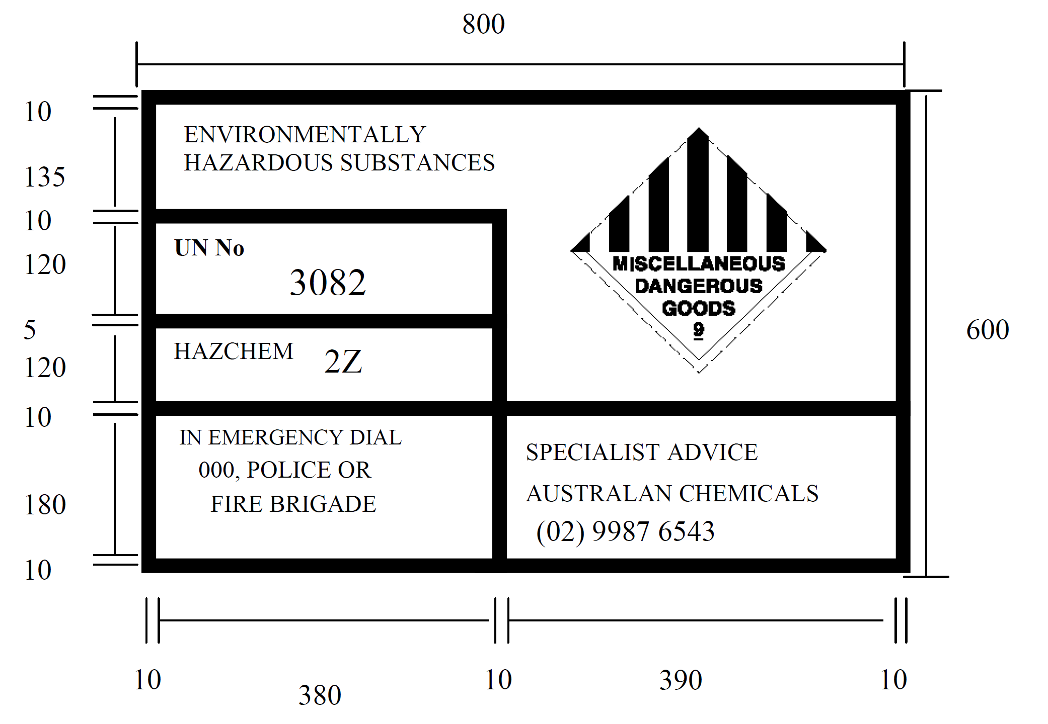
Figure 1: Format of emergency information panel for environmentally hazardous substances (liquid)
Example of a placard used to transport environmentally hazardous substances in bulk (measurements in mm)
The class label within the EIP must be 250 mm on each side unless the waste has a primary hazard and a subsidiary risk (secondary hazard). In which case they should be 200 mm and 150mm respectively. Refer to Figure 5.3.2(a): Format and Colour of Emergency Information Panel of the ADG Code.

EIP format for 30XY non-hazardous waste
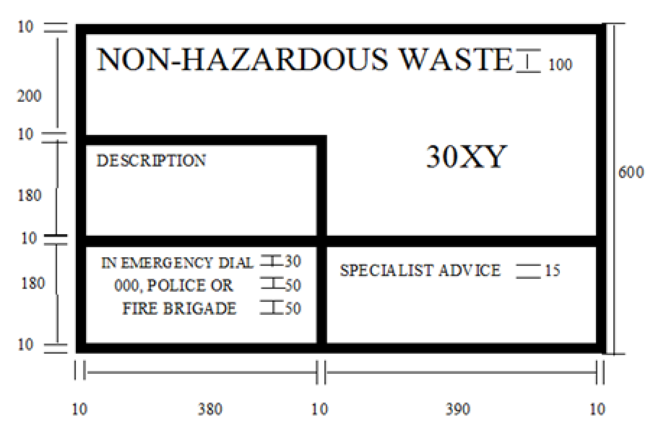
Figure 2: Format of emergency information panel (EIP) for
30XY non-hazardous waste
(measurements in mm)

Positioning of EIPS and class labels
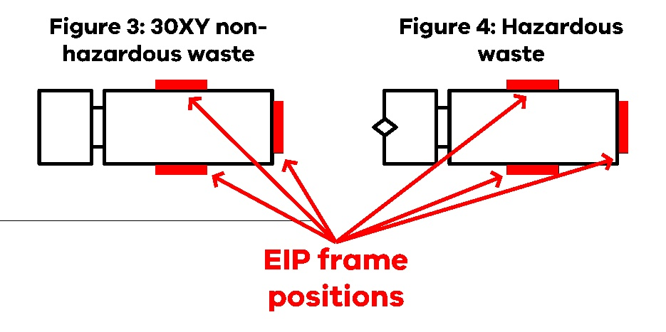
Figures 3 & 4 EIP frame positions
There should be fitted frames to accommodate an EIP or EIPs on each side of the vehicle. There should also be a fitted frame to accommodate an EIP at the rear of the vehicle.
If in the case of an obstruction on the vehicle or tank, it is not possible to mount a full size EIP, a half size panel may be mounted. Half-size panels must have dimensions of not less than half of that shown in the diagrams above.
Refer to the following sections of the ADG Code for more information on the positioning of class, division or mixed labels, and EIPs:
- 5.3.5.4 Placard Location
- 5.3.6 Placarding Road Vehicles
- Figure 5.3.6. Illustrations of Placarding Typical Road Vehicle Configurations

Additional information – tanker types 3 & 4
Big rear doors with a diameter of more than 400 mm, should have a minimum of six closure points. The door should be securely latched into hold downs. If the door operation is automated (pneumatic or hydraulic), the door should remain locked in the event of system failure. The seals should be multi-lip compression seal. Refer to EPA’s Tanker/tanker trailer photo guide for examples of vehicle controls.

References
EPA Victoria (2025) Vehicle safety standards for transporting industrial waste. State of Victoria.
EPA Victoria (2021) Publication 1827.2 Waste classification assessment protocol. State of Victoria.
EPA Victoria (2024) Publication 822.5 Waste codes. State of Victoria.
National Heavy Vehicle Regulator (2023b) Section J – Body Mounting in National Code of Practice VSB6 Heavy Vehicle Modifications Version 3.2. National Heavy Vehicle Regulator.
National Heavy Vehicle Regulator (2024) Waste and Recycling Industry Code of Practice. National Heavy Vehicle Regulator.
National Transport Commission (2024) Australian Code for the Transport of Dangerous Goods by Roal & Rail Edition 7.9, 2024. Commonwealth of Australia.
Standards Australia (2010a). Dangerous Goods – Initial Emergency Response Guide (SAA/SNZ HB 76:2010). https://store.standards.org.au/product/saa-snz-hb-76-2010
Standards Australia (2010b). Pressure vessels (AS 1210-2010). https://store.standards.org.au/product/AS-1210-2010
Standards Australia (2018) Management of clinical and related wastes (AS 3816:2018). https://store.standards.org.au/product/as-3816-2018
Standards Australia (2020) Road tank vehicles for dangerous goods, Part 1: General requirements for all road tank vehicles (AS 2809.1:2020) https://store.standards.org.au/product/as-2809-1-2020
Standards Australia (2021) Road tank vehicles for dangerous goods, Part 3: Road tank vehicles for compressed liquefied gases (AS 2809.3:2021) https://store.standards.org.au/product/as-2809-3-2021
Standards Australia (2022a) Road tank vehicles for dangerous goods, Part 4: Road tank vehicles for toxic, corrosive or ammonium nitrate emulsion, suspension or gel cargoes (AS 2809.4:2022) https://store.standards.org.au/product/as-2809-4-2022
Standards Australia (2022b) Road tank vehicle for Dangerous goods, Part 5: Road tank vehicles for bitumen-based products (AS 2809.5:2022) https://store.standards.org.au/product/as-2809-5-2022
Standards Australia (2023a) Road tank vehicles for dangerous goods, Part 1: General requirements for all road tank vehicles (AS 2809.1:2023) https://store.standards.org.au/product/as-2809-1-2023
Standards Australia (2023b) Road tank vehicles for dangerous goods, Part 2: Road tank vehicles for flammable liquids (AS 2809.2 2023) https://store.standards.org.au/product/as-2809-2-2023
Standards Australia (2024) Freight containers, Part 10: Handling and securing (AS/NZS 3711.10:2024) https://store.standards.org.au/product/as-nzs-3711-10-2024
Transport of Dangerous Goods Competent Authorities Panel (2022). Australian and New Zealand Emergency Response Guide 2021. National Transport Commission.
Victorian Department of Health (2023) Cleaning and waste disposal procedures – infection control. State of Victoria.

Appendix A – Summary table feature/fittings and permitted waste codes
The following Table (see next page) summarises the vehicle features/fittings that your vehicle may have in place depending on the waste codes that you wish to take and the type of vehicle that you have.
Before you select waste codes in your application for a permission to transport RPW, you must assess your vehicle against the vehicle features listed in this Table. For example, tanker type 5 has the following features/fittings, which restricts the permitted waste codes to N120, N121 and T130-H:
- meets the basic requirements (fire extinguisher, suitable spill kit etc.) as specified in this guidance document
- large rear manhole
- capped valves
Any alternative measures that are not mentioned in this guidance, but which give equivalent results, could be considered appropriate, pending further assessment by EPA. If you want to apply for a waste code that does not correspond with the permitted codes, please contact EPA to discuss your permission application further.
A single letter in the ‘waste codes’ column indicates that all waste codes beginning with that letter are acceptable for that type of vehicle with the controls described. For example, ‘H’ includes waste types H100, H110, H160 and H170. A list of waste codes and what they mean can be found in Publication 822.5 Waste codes (EPA Victoria 2024)

Appendix A Table of vehicle feature/fittings and permitted waste codes
Vehicle features/fittings | Guidance section reference | 1. Tanker type 1  (Compliant with Australian Standard AS2809) | Waste Codes |  | 2. Tanker type 2 30XY plus – Rigid tankers or vacuum tankers (30XY streams plus some dangerous goods waste streams) | Waste Codes |  | 3. Tanker type 3 30XY – Vacuum tankers (30XY streams, non-dangerous goods waste) | Waste Codes |  | 4. Tanker type 4 – Gully sucker type | Waste Codes |  | 5. Tanker type 5 – Inert sludges and slurries | Waste Codes
Meets basic requirements (safety equipment, fire extinguisher, suitable spill kit etc.) as specified in this guidance document | 2, 3 & 4 | ü | A100  A110  A130  B100  C100  D140  D300  D390  F  G  H  J  K  L  M  N140  N205  N210  R140  T120  T130-H  T330 |  | ü | A100B100  C100  D140  D300  D390  F  H  J  K  L  M  N140  N205  N210  N220  R140  T120 T130-H  T330 |  | ü | C100  D140  D300  D390  F100  F110  J  K  L  M130  M250  N120  N130  N140  N150  N160  N190  N205  N210  N220  N230  N250  R140  T120  T130-H  T330 |  | ü | F100  F110  H  J130  K  L  M250  N120  N130  N140  N150  N160  N190  N205  N210  N220  N230  N250  T130-H  T330 |  | ü (Spill kit only) | N120  T130-H
Fully compliant with ADG standard (Australian Standard AS2809) | 2, 3, 4, 5, 6, 7 & 8 | ü |  |  |  |  |  |  |  |  |  |  |  |  | N120  T130-H
AS2809 tanker design approval | 7 | ü |  |  |  |  |  |  |  |  |  |  |  |  | N120  T130-H
Tanker baffles  (tank >2.5 metres) | 5.4 | ü |  |  | ü |  |  | ü |  |  |  |  |  |  | N120  T130-H
Small rear manhole | 5.3 |  |  |  | ü |  |  |  |  |  |  |  |  |  | N120  T130-H
Large rear door (*this fitting is a deviation from AS2809) | * |  |  |  |  |  |  | ü |  |  | ü |  |  | ü | N120  T130-H
Minimum six close points or equivalent arrangement (requirement for manholes and rear doors) | 9 | ü |  |  | ü |  |  | ü |  |  | ü |  |  |  | N120  T130-H
Full width rear bumper | 6 | ü |  |  | ü |  |  | ü |  |  |  |  |  |  | N120  T130-H
Rear protection of all fittings | 6 | ü |  |  | ü |  |  | ü |  |  | ü |  |  |  | N120  T130-H
Shut off valve(s) on tank | 5.3 | ü |  |  | ü |  |  |  |  |  |  |  |  |  | N120  T130-H
Hose trays fully sealed | 5.3 | ü |  |  | ü |  |  |  |  |  |  |  |  |  | N120  T130-H
Capped valves | 5.3 | ü |  |  | ü |  |  | ü |  |  | ü |  |  | ü | N120  T130-H
Coaming meets ADG standard | 5.3 | ü |  |  | ü |  |  | ü |  |  |  |  |  |  | N120  T130-H
Roof mounted safety rail or fall protection device (**Occupational Health and Safety (Prevention of falls) Regulations 2003) | ** | ü |  |  | ü |  |  | ü |  |  |  |  |  |  | N120  T130-H

Accessibility
Contact us if you need this information in an accessible format such as large print or audio.
Please telephone 1300 372 842 or email contact@epa.vic.gov.au
Interpreter assistance

If you need interpreter assistance or want this document translated, please call 131 450 and advise your preferred language. If you are deaf, or have a hearing or speech impairment, contact us through the National Relay Service.



epa.vic.gov.au
Environment Protection Authority Victoria
GPO BOX 4395 Melbourne VIC 3001
1300 372 842



Authorised and published by the Victorian Government, 1 Treasury Place, Melbourne

