
  - Publication 1950
August 2024
Policy and Regulation Branch

Landfill buffer guideline


Authorised and published by the Victorian Government, 1 Treasury Place, Melbourne
epa.vic.gov.au
Environment Protection Authority Victoria
GPO BOX 4395 Melbourne VIC 3001
1300 372 84
This content is for general information only. Obtain professional advice if you have any specific concern. EPA Victoria has made reasonable effort to ensure accuracy at the time of publication. Except where noted at epa.vic.gov.au/copyright, all content in this work* is licensed under the Creative Commons Attribution 4.0 Licence. To view a copy of this licence, visit creativecommons.org. EPA acknowledges Victoria’s First Nations peoples as the Traditional Owners of the land and water on which we live and work. We pay our respect to their Elders past and present.


Contents
1 Introduction 5
1.1 Purpose 5
1.2 Scope 6
1.3 Definitions 7
2 Legislative framework 9
2.1 EPA’s role in land use planning for landfills 9
3 Why are risks from landfills an important planning consideration? 11
4 Human health and amenity risks posed by landfills 12
4.1 Landfill gas 12
4.2 Odour 13
4.3 Noise 14
4.4 Litter 14
4.5 Dust 14
5 Landfill buffers 15
5.1 Classifying landfills 15
5.2 Recommended buffers 16
5.3 Buffer for Type 2 putrescible landfills with larger tipping faces 17
5.4 Odour separation distance for Type 3 solid waste landfills 19
6 When to consider landfill buffers 20
6.1 Agent of change principle 20
7 How to measure landfill buffers 22
7.1 Operating landfills 22
8 Assessing planning proposals within the buffer of a landfill 25
8.1 Does the planning proposal fall within a landfill buffer? 26
8.2 Is the landfill operating or closed? 27
9 Assessing the risk of landfill gas impacts 29
9.1 What type of development will the proposal allow? 31
10 Landfill gas risk assessment 34
10.1 Who can conduct a landfill gas risk assessment? 34
10.2 What is a landfill gas risk assessment? 34
10.3 The landfill gas risk assessment process 34
10.4 The potential outcomes of a landfill gas risk assessment 34
10.5 How long should a landfill gas risk assessment take? 34
10.6 EPA’s role in landfill gas risk assessment 34
11 Environmental audit 36
11.1 Who can conduct an environmental audit? 36
11.2 What is an environmental audit? 36
11.3 The environmental audit process for landfill gas 36
11.4 The outcome of an environmental audit 36
11.5 How long does an environmental audit take? 37
12 Landfill gas mitigation measures 38
12.1 What are mitigation measures? 38
12.2 What mitigation measures should be required 38
12.3 Design and verification 39
13 Appropriate land uses within the buffer of operating landfills 40
13.1 Table of land uses 40
Appendix A: Planning context 51
Appendix B: Sources of landfill information 53
Appendix C: Sample planning permit conditions 54

Introduction
Landfills are an important part of Victoria’s waste management infrastructure. However, they can also have impacts on the surrounding environment and community during operation and long after they have closed. At the time of publication, Victoria has more than 80 operating landfills and more than 200 closed landfills
Landfill buffers are an important tool to protect both the continued operation of the landfill and the health and amenity of the surrounding community. They are used to separate landfills and sensitive land uses and to manage the risk of:
- landfill gas migration from operating and closed landfills and
- the human health and amenity impacts from operating landfills, including odour, noise, dust and litter.
Environment Protection Authority Victoria (EPA) developed this guideline to support state and local government, community and industry to make informed land use and development decisions for and around landfills under the Planning and Environment Act 1987 (P&E Act) and the Environment Protection Act 2017 (EP Act).
The guideline is intended to provide all relevant information about buffers for landfills. The guideline provides advice on:
- human health and amenity risks posed by landfills
- separation distances for landfills
- appropriate land uses within landfill buffers.
It also sets out a process to determine the level of assessment a decision-maker (planning authority, responsible authority or state agency) should require informing their land use and development decisions, and recommends a staged, risk-based approach.

Purpose
The purpose of this guideline is to support land use and development decisions that:
- protect human health and amenity from the effects of pollution and waste associated with operating and closed landfills
- protect landfills from inappropriate land use and development nearby that may constrain operations.
This guideline is intended for planning authorities, responsible authorities, industry, developers, the community and EPA. It provides guidance on what to consider when preparing and assessing planning scheme amendments, precinct structure plans and planning permit applications for landfills, or those that would lead to use or development within the buffer of an operating or closed landfill.
EPA will consider this guideline when assessing applications for EPA permissions for landfills, including for development and operating licences and permits. More information about EPA permissions, including for landfills, is available on the EPA website.
This guideline contributes to the state of knowledge – the general body of knowledge about the harm or risks of harm to human health and the environment, including the controls for eliminating or reducing those risks. It is expected that the state of knowledge will improve over time as new knowledge and opportunities to better manage risk are established.
The information in this guideline replaces sections 5.1.5, 8.2.1 and 8.2.2 of Siting, design, operation and rehabilitation of landfills (Landfill BPEM) (EPA publication 788).
Note: For information about recommended separation distances for other uses/activities, please see the Separation distance guideline (EPA publication 1949).

Scope
This guideline is intended to support land use and development decisions for and around landfills under the P&E Act and the EP Act. Compliance with the EP Act, including the general environmental duty (GED) is an obligation on all applicants. Meeting a recommended separation distance or buffer is not a substitute for best practice.
This guideline does not include advice relating to the day-to-day operation and management of a landfill or consideration of groundwater. That advice is contained within the Landfill BPEM.
This guideline is not to be used retrospectively to require an existing landfill operating in accordance with all relevant statutory obligations to comply with a buffer. However, it may be used to determine a buffer to inform land use and development decisions surrounding an existing landfill, or to assess proposed changes to or expansion of an existing landfill where a permission is triggered.
This guideline is not intended to be used to revisit decisions already made by planning decision-makers (for example, planning permits) and EPA (permissions).
This guideline should be applied early in planning processes as separation distances are most effective where they can direct the location and siting of land uses to avoid incompatibility or encroachment. This includes:
- strategic planning processes, including those considering Ministerial Direction 19, and the development of draft strategic plans, including Precinct Structure Plans or planning scheme amendments that have yet to receive final planning authority approval.
- for strategic plans that have received approval, the guideline should be considered for any future assessments within or near the plan area.
- the assessment of permits for use, development, or subdivision for proposed sensitive uses or for industrial uses in an industrial zone that encroaches into sensitive land uses.
The guideline should also be considered where potentially incompatible uses are permissible (no permit required) but the risks of harm to human health or the environment needs to be considered under the EP Act.
Decision-makers should consider the guideline to inform strategic planning processes. It is intended that planning decision-makers and EPA will consider this guideline for applications for a planning permit and/or an EPA permission to expand operations, where relevant. This includes where there is already encroachment between a sensitive use and industry.

Definitions
Separation distance | A separation distance:  - is a distance between incompatible land uses where there are likely to be adverse human health or amenity impacts  - typically occurs between an industrial (or sometimes commercial) land use and a sensitive land use  - is used as a tool to determine whether the siting of a proposed land use or development is suitable in the context of surrounding land uses.
Buffer | A buffer:  - is land used to separate or manage incompatible land uses – often industrial uses and sensitive uses – to ensure land use compatibility and avoid land use conflict  - may contain multiple separation distances that respond to various risks to human health and amenity  - For landfills, the buffer is made up of separation distances responding to multiple risks, including landfill gas, odour and dust. The landfill buffer will extend to the largest of these separation distances.  - does not need to stop the use and development of land – instead, it ensures land use and development responds to the risks posed and allows for a transitional area of land between two distinct land uses to lessen the risk of harm posed by one land use type on another.  Refer to Planning Practice Note 92: Managing buffers for land use compatibility for further information.
Sensitive land use | Whether a land use is deemed sensitive depends on the particular risk posed.  In the context of landfill gas:  - any building or structure including underground infrastructure such as pipelines is considered sensitive, because of the risk of explosion or asphyxiation.  In the context of human health and amenity impacts from landfills (which may include odour, dust, noise and litter):  - any land use or zone that requires a focus on protecting human health and wellbeing, local amenity and aesthetic enjoyment is considered sensitive.  Examples of sensitive land uses include, but are not limited to:  - dwellings and private open space (including detached dwellings, multiple dwellings, flat/apartment buildings, row dwellings and semi-detached dwellings)  - accommodation (excluding caretaker’s residence)  - child care centres  - education centres  - informal outdoor recreation, adjacent to residential zones  - camping and caravan parks  - indoor recreation facilities  - medical centres  - hospitals  - residential aged care facilities and retirement villages  - outdoor recreation facilities, open sports grounds, (regular public use, for example, sporting fields) adjacent to residential zones.  Note: The above land use terms are based on those defined in clause 73.03 (land use terms) and clause 73.04 (nesting diagrams) of the Victoria Planning Provisions (VPP). If the terms in the VPP do not correspond with this list, contact EPA for advice.  Examples of zones that require a focus on protecting human health and wellbeing, local amenity and aesthetic enjoyment include but are not limited to:  - Activity Centre Zone  - Capital City Zone  - Commercial 1 Zone  - Docklands Zone  - Residential zones  - Rural Living Zone.
Closed landfill | Landfill that has ceased accepting new waste

Legislative framework
The P&E Act and the VPP provide the basis for the regulation of land use planning and development. Separation distances are a preventative tool to manage land use conflicts. The EP Act’s intent is embedded in VPP through consideration of the risks and impacts of use and development on human health and the environment.
The EP Act provides a statutory framework for industry and a preventative approach to protecting human health and the environment from the impacts of pollution or waste. Information about the EP Act including the general environmental duty (GED), state of knowledge and what reasonably practicable means can be found on the EPA website.
EPA has guidance available for landfills that contribute to the state of knowledge. This includes (but is not limited to) the following:
- Best practice environmental management – Siting, design, operation and rehabilitation of landfills (Landfill BPEM, EPA publication 788)
- Best practice guidelines for landfills accepting Category C prescribed industrial waste (EPA publication 1208)
- Waste disposal categories – characteristics and thresholds (EPA publication 1828)
- Landfill licensing guidelines (EPA publication 1323).
For further information:
- Appendix A includes a summary of the relevant planning policy references for separation distances for landfill buffers.
- Appendix B includes more detail about where to find information about landfills.

EPA’s role in land use planning for landfills
Land use planning has an important role in achieving the purpose of the EP Act – the protection of human health and the environment from pollution or waste. However, land use and development within separation distances or buffers is not controlled by EPA. Planning and responsible authorities determine permitted land use and development by implementing the planning scheme, including within separation distances. Separation distances are implemented through appropriate planning policies and controls (including zones and overlays), and by making decisions on individual planning permit applications.
EPA’s involvement in land use planning occurs through both statutory and strategic planning mechanisms:
- EPA is a statutory referral authority for some land use planning proposals under the P&E Act. EPA may be a determining or recommending authority as set out in clause 66 of the VPP. Where EPA is a determining referral authority and objects to a proposal, the responsible authority must refuse to grant the permit. When EPA specifies conditions, these must be included on any permit granted.
- EPA can be given notice of an application when the responsible authority wants to seek advice from EPA, but mandatory referral is not required. EPA takes a risk-based approach to these types of referrals.
- Ministerial Direction 19 requires planning authorities to seek early advice from EPA when undertaking strategic planning processes and preparing planning scheme amendments that may significantly impact Victoria’s environment, amenity or human health due to pollution and waste.
- EPA also has a role in proposals to apply the Buffer Area Overlay (BAO). Planning Practice Note 92: Managing buffers for land use compatibility sets out the steps to be taken when considering its application.
This guideline informs EPA’s response to statutory and strategic planning matters where landfill buffers are relevant. EPA uses its environmental expertise to assist planning and responsible authorities with understanding the environmental risks associated with certain planning and development decisions.
It does not change the roles and responsibilities of the planning or responsible authority or EPA.
EPA can assist with land use and development decisions by providing information on the best available techniques and technologies and provide guidance when there is a proposed variation in separation or buffer distances. EPA can also provide guidance for environmental protection and apply regulatory interventions where appropriate.
Under the EP Act, EPA also has a role in assessing applications for new and amended permissions for industry/activities. Depending on the risk and type of activity this may be a licence, permit or registration. Some proposals may require both a planning permit and EPA permission. While EPA’s assessment for both will consider the impact and risk of harm from pollution and waste, the planning assessment focuses on the land use being proposed, and whether it is sited appropriately and compatible with surrounding uses. The permission assessment focuses on the design and operation of the activity. The trigger for the assessment is also under different Acts – the EP Act and the P&E Act.

Why are risks from landfills an important planning consideration?
Landfills are an important part of Victoria’s waste management infrastructure. However, they can also have impacts on the surrounding environment and community during operation and long after they have closed. In particular:
- Operating landfills can discharge landfill gas, offensive odour, noise, litter and dust.
- Closed landfills can discharge landfill gas for many decades after they last
accept waste.
At the time of publication, Victoria has more than 80 operating landfills and more than 200 closed landfills. It is also worth noting, that there are inactive and informal or legacy landfills across Victoria with little or no historical information publicly available. These are difficult to manage through the planning process. If an applicant or council is aware of such cases, the assessment process in this guidance can be used to determine the appropriate level of assessment.
Landfill buffers are used to separate landfills and sensitive land uses and to manage the risk of:
- landfill gas migration from operating and closed landfills
- human health and amenity impacts from operating landfills, including odour, noise, dust and litter.
Landfill buffers are not an alternative to landfill operators meeting their statutory obligations, including controlling offsite impacts. Landfill buffers recognise that even when landfills are operating in accordance with all relevant statutory obligations, there will still be offsite impacts. Landfill buffers are an important tool to protect both the continued operation of the landfill and the health and amenity of the surrounding community.
Protection of landfill buffers is particularly important given that landfill gas can be discharged for many decades after waste is last accepted. The exact amount of time varies for each landfill and depends on a range of operational and environmental conditions.

Human health and amenity risks posed by landfills

Landfill gas
Landfill gas is primarily generated by the decomposition of organic waste in a landfill. It poses a human health and amenity risk for operating and closed landfills.
The amount of landfill gas generated depends on the size and age of the landfill and the type of waste within it. Putrescible waste (such as household waste) degrades more quickly than solid waste (such as construction waste) and produces more landfill gas.
Landfill gas continues to be generated within a landfill for many years after the landfill stops accepting waste. Peak production of landfill gas generally occurs one to 2 years after waste is last placed, but it can continue to be produced for many decades. This is consistent with the EP Act, which allows 99-year landfill licences due to the long-lasting impacts of landfill gas.
Landfill gas can be flammable, explosive, toxic, corrosive, odorous, and present an asphyxiation (suffocation) hazard.
The risk posed by landfill gas to nearby development depends on the:
- source and magnitude of the gas hazard (including surface emissions)
- pathway (likelihood of gas reaching the development and accumulating in such volumes and concentrations to become dangerous)
- receptor (sensitivity of the development).

Source
If there is a build-up of landfill gas pressure in a landfill, the gas can move outward and upward. The risk is influenced by the extent/size of the gas hazard.

Pathway
The landfill gas pathway will be affected by:
- the design of the landfill – best practice landfill design includes landfill liners, leachate collection systems, landfill gas extraction and treatment systems and landfill caps to reduce the risk of vertical landfill gas migration
- the geology of the subsurface between the landfill and the receptor – permeable geologies such as sands and fractured rock allow landfill gas to migrate more easily than less permeable geology such as clay.

Receptor
Landfill gas accumulation in buildings and structures poses a risk to human health.
Underground service utilities in proximity to landfills can also be preferential pathways for landfill gas.
Gas can enter buildings through:
- gaps around pipes and service entries
- gaps and cavities in walls
- cracks in floors
- cracks and gaps in basements.
Gas can accumulate in confined spaces, such as:
- wall cavities
- beneath floor slabs
- within voids, including roof voids
- drains.
Figure 1 show examples of landfill gas exposure pathways.
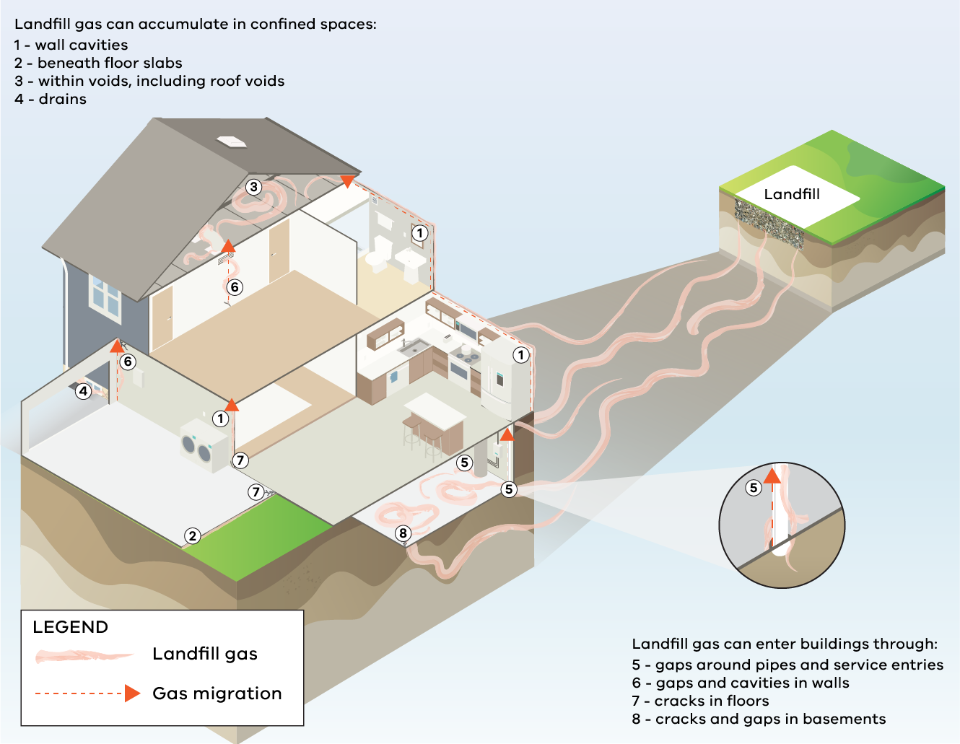
Figure 1. Examples of landfill gas exposure pathways

Odour
Odour from an operating landfill can be caused by a range of operational issues but generally falls into 3 categories:
- fresh waste odour (surface emissions)
- landfill gas odour
- other odours, such as from sub-surface hotspots.
Landfill owners and operators are required to take all reasonably practicable measures to minimise odour impacts from their operations. However, there will be instances where odour issues will occur even when all reasonably practicable controls are in place.
The primary causes of fresh waste odour are:
- lack of a cover over the waste at the end of the day’s operations – it may not be deep enough to cover the waste, or an inappropriate type of material has been used
- poor tipping face management, resulting in an excessively large area of fresh waste being exposed at the end of the day
- poor acceptance procedure, which fails to identify highly odorous loads that need to be covered immediately.
The primary causes of landfill gas odour are more complex, but at a high level include:
- poorly performing (or lack of a) landfill gas collection system
- inadequate capping – this could contribute to landfill gas coming through the cap or limit the ability to draw gas from the waste mass
- poor leachate management – leachate can be an odour source in itself and also lead to the gas extraction system becoming flooded and limiting its ability to remove gas from the waste mass.
The primary causes of hotspot odour are:
- hotspots are generally formed when air enters the waste mass through the over extraction of landfill gas, open leachate sumps, migration through cracks or fissures in batters or areas of the landfill with thin cover material. They can also occur due to the burial of hot loads and by chemical and biological reactions as the waste breaks down
- hotspots typically occur in operating landfills. Once established they can be difficult to extinguish and can result in offsite odour for several months to years.

Noise
Noise from an operating landfill can be caused by:
- trucks, including engine and exhaust noise and reversing beepers
- communications systems, such as PA systems and external telephone bells
- machinery and equipment used for resource recovery operations, for example, concrete crushing equipment.

Litter
Litter, such as plastic bags, may be carried by the wind and impact areas near the landfill.
Offsite litter impacts are influenced by:
- weather – greater impacts may be expected on windy days
- orientation and elevation of the tipping area in the landfill
- the litter control strategy of the landfill, which may include measures such as litter screens and fencing.

Dust
Dust can be generated by traffic associated with the landfill, earth stockpiles at the landfill or the delivery of dusty loads.
Dust impacts are influenced by:
- weather – greater impacts may be expected on windy days
- presence of natural or constructed windbreaks
- dust suppression activities (sprinklers etc.)
- whether the roads within or to the landfill are sealed or unsealed.

Landfill buffers

Classifying landfills
Landfills are classified according to the type of waste they accept. Different recommended buffers apply depending on the type of waste accepted.
This guideline includes recommended buffers for Type 2 and 3 landfills (see Table 1). These types of landfills may accept the following waste:
- putrescible (municipal) waste, such as household wastes
- category C priority waste as defined in the Environment Protection Regulations 2021
- solid waste, such as construction wastes
- fill material.
Further information on landfill classification may be found in EPA Publication 788 and on the Victorian Landfill Register available on the EPA website.
Table 1 Classification of landfills
Type | Waste accepted | Description
1 | Priority waste including Category B waste as defined in Schedule 6 of the Environment Protection Regulations 2021  Waste disposal categories – characteristics and thresholds (EPA publication 1828) | Contact EPA for advice.  Type 1 landfills are complex and are not covered in this guidance.
2 | Putrescible (municipal) waste, solid waste and fill material.  Some sites may also be licensed to receive specific types of priority wastes (Category C, asbestos etc.) | Reflects the best available technology for a municipal landfill in siting, design, construction, operation, maintenance and after-care.  Operated in accordance with an appropriate management system that ensures adequate supervision, control on waste receipt, safe handling, record keeping and placement of prescribed waste in accordance with the requirements for that waste.
3 | Solid waste, fill material. | Reflects the best available technology for a municipal landfill in siting, design, construction, operation, maintenance and after-care.

Recommended buffers
Table 2 summarises the recommended buffers for different landfill types. This includes separation distances to account for:
- landfill gas migration
- human health and amenity risks (odour, dust, noise, litter)
- safety considerations, including bird strike
- protection of surface waters.
The buffers should be applied to a new, expanding or varied landfill, and to new or varied use or development close to a landfill. Section 7 provides detailed information on how to measure buffers for both closed and operating landfills. The licenced tipping face size is listed on the EPA licence available in EPA’s Permissioning decisions register.
Table 2. Landfill buffers
Landfill type | Buffers
Landfill accepting municipal (putrescible) waste (Type 2)  Licenced tipping face up to 900 m² | Landfill gas:  - 500 m from buildings or structures  Human health and amenity impacts:  - 500 m from sensitive land uses. This may be varied with an appropriate odour/landfill gas risk assessment or audit that demonstrates an alternative buffer is acceptable.  Water quality:  - 100 m from surface waters  Bird strike:  - 1,500 m from an aerodrome for piston-engine propeller-driven aircraft*  - 3,000 m from an aerodrome for jet aircraft*
Landfill accepting municipal (putrescible) waste (Type 2)  Licenced tipping face equal to or greater than 900 m² | Landfill gas:  - 500 m from buildings or structures  Human health and amenity impacts:  - 1,500 m from sensitive land uses. This may be varied to a minimum of 1,000 metres with an appropriate odour risk assessment that demonstrates an alternative buffer is acceptable (refer to Guidance for assessing odour (EPA publication 1883)).  Water quality:  - 100 m from surface waters  Bird strike:  - 1,500 m from an aerodrome for piston-engine propeller-driven aircraft*  - 3,000 m from an aerodrome for jet aircraft*
Type 2 landfill not licenced to accept putrescible waste | Case by case  - Supported by an appropriate landfill gas risk assessment (Refer to Sections 9 and 10 of this guideline)
Landfill accepting solid waste (Type 3) | Landfill gas:  - 200 m from buildings or structures  Human health and amenity impacts:  - 500 m from uses sensitive to odour  - 200 m from uses sensitive to dust  Water quality:  - 100 m from surface waters  Bird strike:  - 1,500 m from an aerodrome for piston-engine propeller-driven aircraft*  - 3,000 m from an aerodrome for jet aircraft*
* A lesser distance may apply subject to the approval of the relevant aviation authority.

Buffer for Type 2 putrescible landfills with larger tipping faces
Recent studies (Bydder & Demetriou, 2019, Bydder, Mesquita, Fedele 2024)) have shown that operating landfills with larger licensed tipping faces require a larger human health and amenity buffer than was specified in earlier guidance, including the Landfill BPEM. Figure 2 shows that as the tipping face size increases, so does the distance of the odour plume.

Figure 2: Odour frequency distributions for obvious odour for the four Melbourne landfills with greater than 900 m² tipping faces at 500 m bands from the tipping face.
Odour impacts from Type 2 putrescible landfills with a licenced tipping face greater than 900 m² can be significant. Because of this, the recommended human health and amenity buffer as listed in Table 2 is 1,500 m.
A proponent may seek to vary this distance (to no less than 1,000 m) if they can provide the decision-maker with a risk assessment that demonstrates that an alternative buffer is acceptable. This minimum distance is based on substantial evidence collected over time demonstrating the significant risk of harm to communities within 1,000 m from large putrescible landfills.
Table 3 provides information on the suitability of sensitive land uses within the buffer.

Table 3. Suitability of sensitive uses within the buffer of a Type 2 operating landfill with a licenced tipping face greater than 900 m²
Buffer for a Type 2 operating landfill with a licenced tipping face greater than 900 m² | Are sensitive uses suitable?
Up to 1,000 m | No.  Evidence shows that sensitive uses are not suitable within the 1,000 m distance due to offsite odour impacts even when a landfill is operating in accordance with all relevant statutory obligations.
1,000 – 1,500 m | May be considered with appropriate assessment to justify suitability.  Sensitive land uses may be suitable, subject to a risk assessment. Impacts may be variable within this distance and therefore not all uses are appropriate.
>1,500 m | Yes.  At distances >1,500 m the human health and amenity risk is low and therefore all uses may be considered.

Odour separation distance for Type 3 solid waste landfills
Recent experience has shown that subsurface hotspots can develop in operating solid waste landfills and due to the changing nature of wastes deposited to these landfills landfill gas generation can commence earlier than in the past and generate odour that can be detected up to and beyond 500 m from the landfill.
EPA has determined that because of this risk, solid waste landfills accepting construction and demolition waste require separation from sensitive uses greater than the 200 m prescribed for dust impacts only. This has been reflected in the recommended 500 m odour separation distance for solid waste landfills (Table 2).
For information on separation distances for closed landfills, including Type 3 landfills, see Section 8.2.

When to consider landfill buffers
Landfill buffers should be considered when preparing or assessing:
- planning scheme amendments, planning permit applications and EPA permissions applications for new, expanded or varied landfills
- planning scheme amendments, precinct structure plans and planning permit applications that would lead to land use or development within the buffer of an operating or closed landfill.
Expanded or varied landfills could include:
- approved or applications under consideration to expand airspace or the physical footprint under an EPA permission and/or planning permit
- future airspace or expansion earmarked in an approved strategic plan
Section 8 of this guideline provides information to assist planning and responsible authorities in assessing planning proposals within the buffer of a landfill.

Agent of change principle
The agent of change principle requires the person or entity proposing a land use or development (new or expanding, modified or varied) that may result in conflicting land uses, to provide evidence to the decision-maker that any variation from a specified separation distance is appropriate. The agent of change has the responsibility to:
- consider their obligations under the GED including the risks of harm to human health or the environment from pollution or waste from the proposed activity
- avoid land use conflicts
- ensure potential impacts on nearby land uses are appropriately mitigated and managed.
The agent of change principle applies to both individual applications and strategic planning matters. Depending on the proposal, the agent of change could be either the industry or the sensitive land use/development.
It is the responsibility of the agent of change to review and understand this guideline and provide evidence to the relevant planning and/or responsible authorities that the landfill buffer has been considered appropriately.
The following are examples of proposed sensitive land use or development as the agent of change:
- planning permit applications for sensitive land use or development close to an operating, closed or proposed landfill
- strategic planning matters involving a new residential, education, mixed-use or other zone or precinct permitting sensitive land uses close to an operating, closed or proposed landfill
- development of a precinct structure plan or local land use policy/strategy close to an operating, closed or proposed landfill.
The following examples demonstrate situations where the proposed use or development of industry is the agent of change:
- planning permit applications for a proposed new or expanding landfill
- strategic planning matters involving an existing or proposed waste and resource recovery precinct/use
- development of a local land use policy/strategy relating to waste and resource recovery
- development licences/operating licences for a proposed landfill or expanding an existing landfill.
Agent of change principle example
A landowner owns a large parcel of land that has been used for farming on the outskirts of a township. Thinking that the site would be perfect for residential development, the landowner proposes to rezone and develop the land for sensitive uses. However, the farm is within the buffer of a closed landfill. It is the responsibility of the landowner to demonstrate that the proposed land use will not be at risk of harm by the landfill gas risk posed by the former landfill.
In these circumstances:
- the development proposal triggers the need to consider the landfill buffer
- the proponent of the development proposal is the agent of change.

How to measure landfill buffers

Operating landfills
For operating landfills, the separation distances that make up the buffers should be measured from the outer boundary of the landfill activity that poses a landfill gas or amenity risk, such as a landfill cell (active, closed or future) or leachate pond, to:
- the nearest sensitive land use (for odour and dust)
- the nearest building or structure (for landfill gas migration).
Future cells could include:
- approved or applications under consideration to expand airspace or the physical footprint under an EPA permission and/or planning permit
- future airspace or expansion earmarked in an approved strategic plan
The figures below show the various methods for measuring separation distances that make up landfill buffers. For further information refer to the Separation distance guideline (EPA publication 1949).

Odour and dust – the urban method
The urban method measures the separation distance from the activity boundary of the landfill activity posing the amenity risk to the property boundary of the nearest sensitive land use, as illustrated in Figure 3.
The urban method should be applied where the nearest sensitive land use is either:
- in an urban area or township, or
- on a site less than 4,000 m², or
- in a zone allowing subdivision to less than 4,000 m².
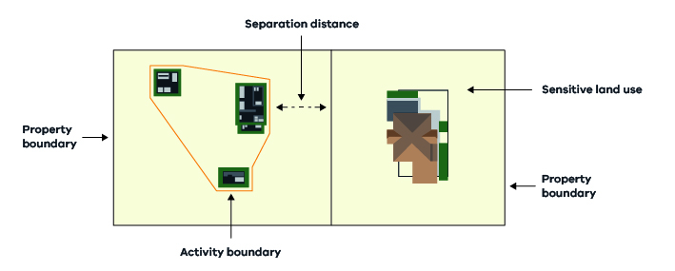Figure 3. Measuring separation distances for odour and dust – the urban method

Odour and dust - the rural method
The rural method measures the separation distance from the activity boundary of the landfill activity posing the amenity risk to the activity boundary of the sensitive land use, as illustrated in Figure 4. The activity boundary of the sensitive land use is the area (within a convex polygon) that includes all current or proposed sensitive uses (including residences, garages and carports, barbecue areas, clotheslines and swimming pools).
The rural method should be applied where the nearest sensitive land use is both:
- not in an urban area or township, and
- on a site at least 4,000 m², or in a zone requiring subdivision to be at least 4,000 m².
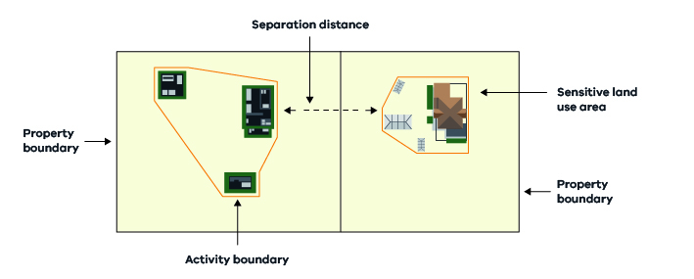Figure 4. Measuring separation distances for odour and dust – the rural method

Landfill gas migration
For operating landfills, separation distances for landfill gas should be measured from the outer boundary of the landfill cells to the nearest building or structure (Figure 5). This includes active, closed and future cells.
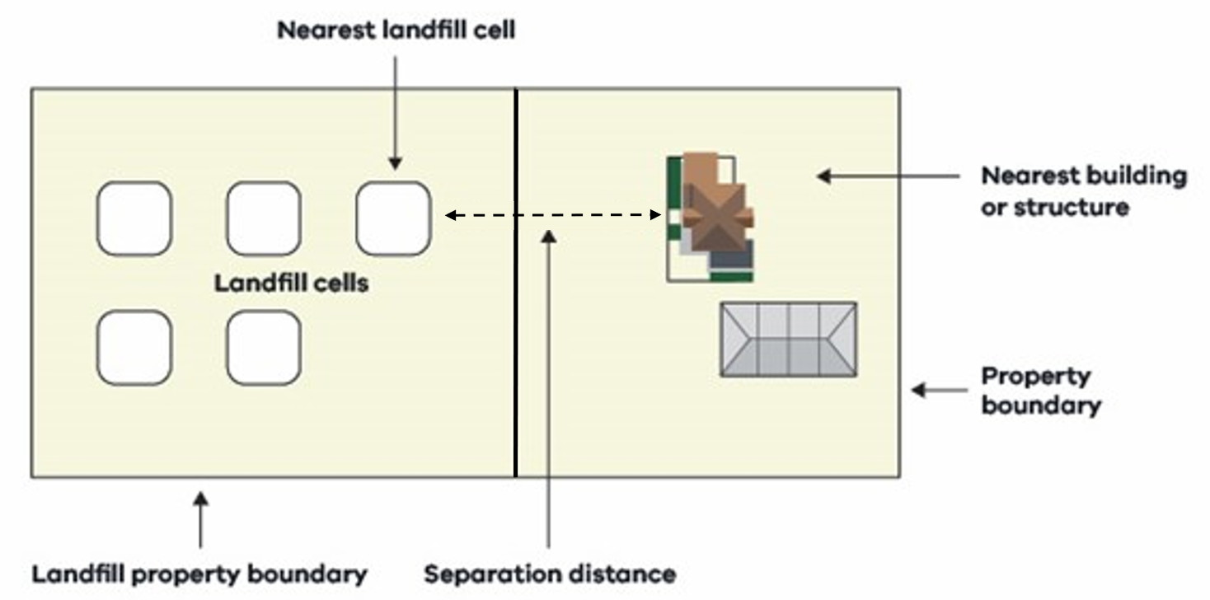
Figure 5. Measuring landfill gas migration separation distances for operating landfills
For closed landfills, only the separation distance for landfill gas migration makes up the buffer. This distance should be measured from the outer boundary of the closed landfill cells to the nearest building or structure.
If the landfill cell locations are unknown, the boundary of the landfill premises should be used instead.
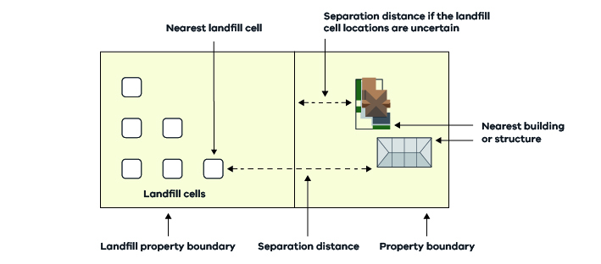
Figure 6. Measuring separation distances for closed landfills

Assessing planning proposals within the buffer of a landfill
Protecting landfill buffers for operating and closed landfills from the encroachment of sensitive land uses is critical to protect human health and amenity. This is relevant in greenfield areas, but also in the context of infill development in existing residential areas.
For operating landfills: failure to preserve appropriate buffers and maintain compatible land uses within the buffer may result in unacceptable offsite impacts. These impacts may affect the health and amenity of the surrounding community and limit future landfill development. The risks include odour, dust, noise and landfill gas migration.
For closed landfills: failure to preserve an appropriate buffer may result in serious landfill gas impacts, including potentially life-threatening risks, such as explosion and/or asphyxiation.
When development is proposed around landfills, the following risks must be considered:
- landfill gas (from operating and closed landfills)
- human health and amenity impacts, such as odour, dust and noise (from operating landfills).
Figure 7 shows an overview of the recommended approach for assessing planning proposals within the buffer of a closed or operating landfill. It steps through questions about the proposal to determine the level of risk and the type of assessment recommended.
Note: where a BAO (or other planning control that includes requirements for assessment of risk) applies to land in a landfill buffer, planning permit applications and planning scheme amendments must assess risk in accordance with the requirements of that control.
Note: for landfills with an anticipated lifespan exceeding 10 years, an analysis of the anticipated changes in the zoning or land use of the surrounding area during the life of the facility should be conducted. Failure to preserve an appropriate buffer and maintain compatible land uses within the buffer may result in unacceptable offsite impacts that limit the future operation of the landfill.
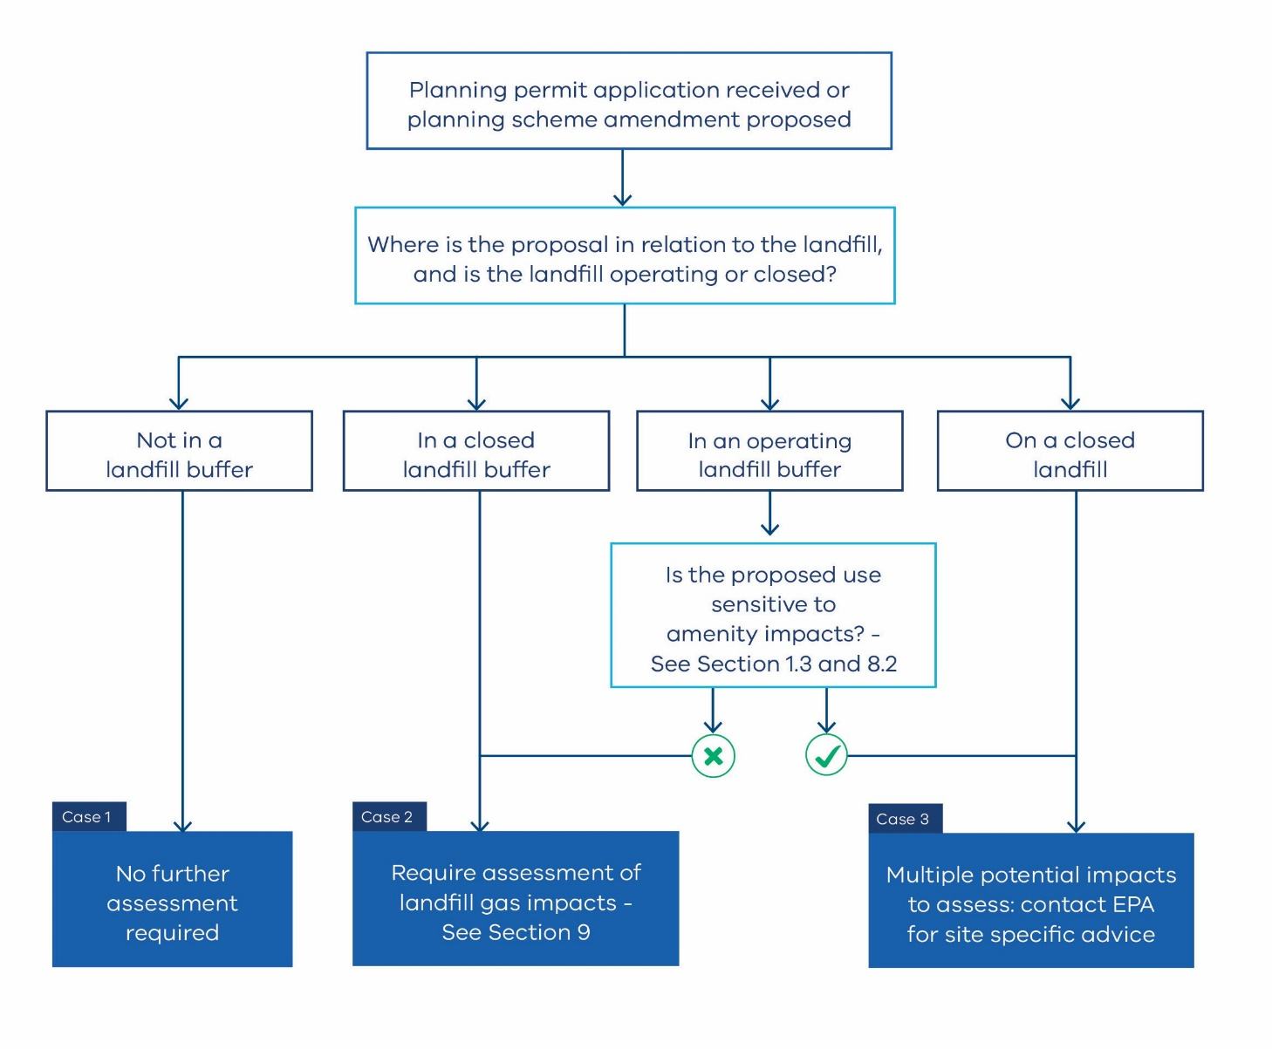
Figure 7. Recommended approach to assess planning proposals within the buffer of a landfill
To begin the assessment process, the applicant should address the following questions:
- Does the planning proposal fall within a landfill buffer? If so;
- Is the landfill operating or closed?

Does the planning proposal fall within a landfill buffer?
To work out whether a planning proposal falls within a landfill buffer, consider that the landfill buffer may be either:
- the recommended buffer set out in this guideline, or
- a site-specific buffer determined by the council (which may be represented by a BAO).
Councils may determine – in accordance with a risk assessment/audit – site-specific buffers that reflect the risk posed by individual landfills. For example, buffers for closed landfills can often be reduced as the risk decreases over time. This determination relates to all the land surrounding the landfill, not just one site.
Providing guidance on site-specific buffers is not within the scope of this guideline. Planning Practice Note 92: Managing buffers for land use compatibility includes detailed information about applying the BAO. Councils can also request EPA’s advice on developing an appropriate process to determine site-specific buffers in their municipality. Generally, this involves gathering and assessing site-specific landfill information with the assistance of a professional environmental consultant with demonstrated experience in assessing risks to developments from landfills.
If the proposal does not fall within the landfill buffer, no further assessment relating to the potential impacts of that landfill is required. (Case 1, Figure 7)
If the proposal does fall within the landfill buffer, proceed to Section 8.2.
Appendix B provides guidance on where to find landfill information, such as an EPA licence and approvals, the EPA Public Register and other useful links.

Is the landfill operating or closed?

Closed landfill
If the buffer is for a closed landfill, the assessment of whether a planning proposal may be appropriate can be limited to the risk of landfill gas impacts only. (Case 2, Figure 7)
This does not mean there is no risk of human health and amenity impacts from a closed landfill. For instance, there may be landfill gas-type odour before a landfill has been capped. However, the potential odour impacts from a closed landfill are significantly less than those of an operating landfill, so it is appropriate for the assessment within a closed landfill buffer to be based solely on landfill gas migration.
For the recommended approach to assessing planning proposals within a closed landfill buffer, refer to Section 9.
If the proposal is on the site of a closed landfill (not just in the buffer), the applicant should contact EPA for advice (Case 3, Figure 7). Many variables influence the risks associated with building on a closed landfill and EPA can assist with site-specific advice.

Operating landfill
If the buffer is for an operating landfill, the risk of landfill gas as well as human health and amenity impacts should be assessed. The type of assessment recommended will depend on whether the proposed use is sensitive to human health and amenity impacts as defined in Section 1.3 of this document:
- Where the proposed use is not sensitive to human health and amenity impacts (Case 2, Figure 7) go to Section 9.
- Where the proposed use is sensitive to human health and amenity impacts (Case 3, Figure 7) the planning authority and responsible authority are recommended to refer the application to EPA for site-specific advice.
The assessment of proposed sensitive use within the buffer of operating landfills is complex. Ultimately the planning and responsible authority are the statutory decision-makers. However, if consulted EPA generally does not recommend sensitive land uses within the buffer of an operating landfill for the following reasons:
- Operating landfill risks may change with time. This can be because of upset operating conditions, the changing location of the tipping face within the landfill, or if the landfill expands in the future.
- Landfill gas risk will continue to change as new cells are filled with waste and long after the landfill has closed.
- If amenity impacts occur at a development site, there may be no way to mitigate these through protective design measures at the development.
Section 13 of this guideline provides guidance on non-sensitive land uses that may be suitable within the buffer of an operating landfill.

Assessing the risk of landfill gas impacts
This section provides a standard, risk-based approach for planning and responsible authorities to determine the appropriate level of assessment for landfill gas risks. Section 8 specifies when this approach should be applied.
This approach applies to planning proposals within the buffer of a closed landfill, or for planning proposals that are not sensitive to human health and amenity risks within the buffer of an operating landfill. In these cases, landfill gas risk is the primary concern (Case 2 in Figure 7).
The approach outlined below should only be applied to Case 2 planning proposals (refer to Figure 7).
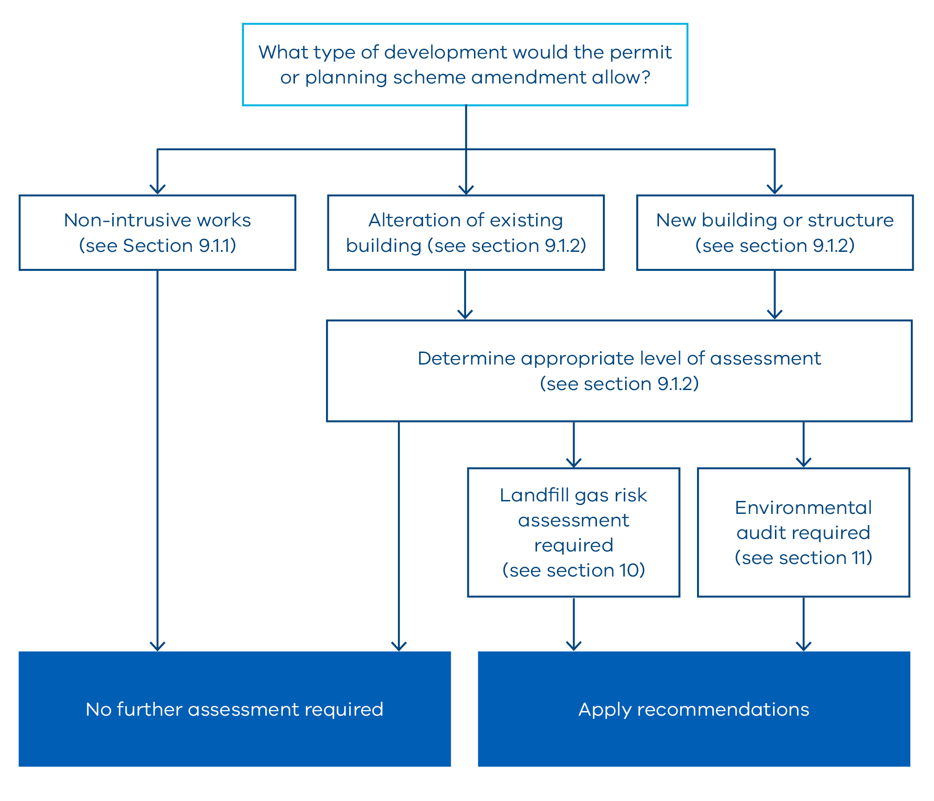
Figure 8. Recommended approach for assessing the risk of landfill gas impacts

What type of development will the proposal allow?
The level of assessment required depends on the type of development the proposal will allow and whether there are intrusive or non-intrusive works involved.

Development proposing non-intrusive works
Proposals for non-intrusive works do not need to be assessed for risk of landfill gas impacts.
Non-intrusive works are those that do not involve enclosed structures, excavation or significant ground disturbance. They include, but are not limited to:
- alterations to buildings and structures that do not require ground disturbance
- fencing
- street and park furniture
- vehicle crossovers
- satellite dishes
- minor signage.

Development proposing alterations to an existing building or new building or structure
EPA recommends that planning and responsible authorities use the following four-step approach to determine the level of assessment required of the risk of landfill gas impacts, if any:
Step 1: Assign a proposal score
Step 2: Assign a landfill score
Step 3: Use the proposal score and landfill score to calculate an overall score
Step 4: Determine the level of assessment required.

Step 1: Assign a proposal score
Step 1 involves reviewing the planning permit application or planning scheme amendment and assigning the proposal a score using Table 4.
Table 4. Proposal scores
Score | Proposal type
1 | Alterations to an existing building using a similar construction style and standards (excluding below-ground structures)
2 | Buildings and structures that exclude below-ground structures, such as basements or lift shafts
3 | Buildings and structures that include below-ground structures, such as basements or lift shafts
Note 1: For planning scheme amendments, a planning authority should consider what type of development the amendment would allow, either as of right or with a planning permit. A precautionary approach should be taken. For example, if land is proposed to be rezoned from Farming Zone to General Residential Zone, the amendment would allow further development and that development may foreseeably include below-ground structures, so a score of 3 should be applied. If additional measures are imposed to preclude below-ground structures, a score of 2 should be applied.
Note 2: For subdivision applications, a responsible authority should consider what type of development the subdivision would allow, either as of right or with a planning permit. If the subdivision would result in lots that could subsequently be developed as of right, the subdivision stage is the last opportunity in the planning process to require appropriate consideration of the landfill gas risk. If the subdivision would result in lots that would require a permit to develop, it is nevertheless appropriate for the risk of landfill gas to be assessed at the earliest available opportunity. For subdivision applications, a score of 3 should be applied unless measures are imposed to preclude below-ground structures, in which case a score of 2 should be applied.

Step 2: Assign a landfill score
Step 2 involves reviewing the information available to identify the key characteristics of the landfill, namely its:
- size (the volume of the landfill in m³)
- type (the predominant type of waste disposed in the landfill)
- age (from the approximate date waste was last disposed of at the site).
Appendix A sets out potential sources of information for these criteria.
Table 5 should then be used to calculate an aggregate landfill source score by adding the scores for each of the size, type and age criteria.
Table 5. Landfill scores
Score | Landfill size
1 | Less than 50 m³
2 | 51 to 500,000 m³
3 | 500,001 to 2,000,000 m³
4 | 2,000,001 to 5,000,000 m³
5 | More than 5,000,000 m³ or unknown size
Score | Landfill type
1 | Soil
3 | Solid waste
5 | Putrescible waste or unknown type
Score | Landfill age
1 | More than 50 years since waste was last placed
2 | 30 to 50 years since waste was last placed
3 | 10 to 30 years since waste was last placed
4 | Fewer than 10 years since waste was last placed
5 | Operating landfill or unknown age

Step 3: Use the proposal score and landfill score to calculate an overall score
Step 3 is to multiply the proposal score by the landfill score to calculate an overall score.
Overall score: proposal score x landfill score (landfill size + type + age)

Step 4: Determine the level of assessment required
Step 4 is to apply the overall score to Table 6 to determine the level of assessment.
Table 6: Determining the level of assessment
Overall score | Level of assessment
1–8 | No further assessment
9–25 | Require a landfill gas risk assessment (see Section 10)
26–45 | Require an environmental audit (see Section 11)
Note 3: If the overall score determines that a landfill gas risk assessment or environmental audit is required, the assessment or audit should be done at the beginning of the planning process. Although there is no statutory trigger for this upfront assessment, EPA recommends the assessment be done as early in the process as practical. If this is not possible, a risk assessment or environmental audit may also be required through planning permit conditions or planning controls implemented as part of a planning scheme amendment. Example planning permit conditions are set out in Appendix C.
Note 4: Where the development also relates to potentially contaminated land and an environmental audit requirement already applies, it may be possible to incorporate landfill gas assessment into this process. In these circumstances, a separate landfill gas risk assessment would not be necessary. Contact EPA for advice.

Landfill gas risk assessment

Who can conduct a landfill gas risk assessment?
A landfill gas risk assessment should be conducted by a suitably qualified environmental consultant with demonstrated experience in conducting landfill gas risk assessments for developments near landfills. The planning permit applicant or planning scheme amendment proponent should engage this person. EPA’s website has guidance about engaging environmental consultants.

What is a landfill gas risk assessment?
A landfill gas risk assessment should include:
- A conceptual site model, based on the characteristics of the landfill and proposal and the likely pathways of gas migration and exposure at the proposed development site.
- Sufficient environmental monitoring from the proposal site to inform the assessment and enable the environmental risks to be characterised (magnitude and likelihood of hazard).
- An assessment of the environmental risk posed by the landfill to the proposed development site in accordance with a recommended methodology (see 10.3).
- Site-specific recommendations for further action (including mitigation measures for the buildings and structures at the proposed development site, if necessary).

The landfill gas risk assessment process
EPA recommends that landfill gas risk assessments follow the methodology in either:
- Assessing risks posed by hazardous ground gases to buildings (Construction Industry Research and Information Association (CIRIA), publication 665:2007) or
- Code of practice for the design of protective measures for methane and carbon dioxide ground gases for new buildings (British Standard 8485:2015+A1:2019).

The potential outcomes of a landfill gas risk assessment
A landfill gas risk assessment should recommend:
- what, if any, mitigation measures are required
- what, if any, further assessment is required (such as monitoring or the need for an environmental audit to be conducted).

How long should a landfill gas risk assessment take?
A landfill gas risk assessment will typically take one to 24 months (as outlined in the relevant standards CIRIA publication 665:2007). The time required will depend on the type and frequency of environmental monitoring required to inform the assessment.

EPA’s role in landfill gas risk assessment
EPA has a statutory role in regulating gas emissions from landfills through development and operating licences and notices under the EP Act. EPA also administers the environmental audit system under Part 8.3 of the EP Act.
A planning or responsible authority can request EPA’s advice on specific planning proposals by providing notice to EPA of relevant planning scheme amendments or planning permit applications under the P&E Act.
EPA’s role in providing advice on planning proposals does not extend to the review of individual landfill gas risk assessments on behalf of councils. Where an independent review of a landfill gas risk assessment is warranted, councils may choose to arrange for a peer review of the report by a suitably qualified environmental consultant with demonstrated experience in conducting landfill gas risk assessments for developments near landfills.

Environmental audit

Who can conduct an environmental audit?
EPA appoints environmental auditors under the EP Act and regulates their conduct. Only an EPA-appointed auditor can conduct an environmental audit. The auditor should be engaged by the planning permit applicant or planning scheme amendment proponent.

What is an environmental audit?
An environmental audit (Part 8.3 EP Act) assesses the risk of harm to human health or the environment from contaminated land, waste, pollution or any other activity. It is conducted by an EPA-appointed environmental auditor and on completion an environmental audit statement and environmental audit report are prepared.
The purpose of an environmental audit is:
- to assess the nature and extent of the risk of harm to human health or the environment from contaminated land, waste, pollution or any activity
- to recommend measures to manage the risk of harm to human health or the environment from contaminated land, waste, pollution or any activity
- to make recommendations to manage the contaminated land, waste, pollution or activity.
Environmental audits are scoped by the auditor according to the site and the risks posed.

The environmental audit process for landfill gas
An environmental audit that considers the risk assessment should be undertaken in accordance with the EP Act and should include the following steps:
- client engages auditor to conduct an environmental audit
- client and auditor define and agree on the audit scope and objectives
- audit scope is submitted to EPA
- auditor reviews existing information, including landfill gas risk assessment
- auditor collects and verifies evidence to support findings relating to audit criteria
- auditor evaluates data to determine compliance with audit criteria
- auditor prepares audit report stating the auditor’s professional opinion on the risk of harm posed by the activity to human health or the environment, with justification
- auditor provides a copy of the environmental audit statement and environmental audit report to the client and EPA. (Details of the statement will be made available on the EPA public register).

The outcome of an environmental audit
At the end of the audit, the auditor must prepare an environmental audit statement accompanied by an environmental audit report. Section 211 of the EP Act sets out what must be included in an environmental audit statement.
For an audit scoped to assess the landfill gas risk, the audit report would include conclusions on whether a landfill gas migration risk exists at the audit site and, if so, recommendations for mitigation measures. It will not include a statement about the suitability of the land for a proposed use at the audit site.
If an audit is required, an applicant may use relevant information from a previous assessment or audit, where it is sufficient.

How long does an environmental audit take?
Based on audits conducted to date, an environmental audit to assess landfill gas risk will typically take 2 to 24 months. The time required will depend on the type and frequency of environmental monitoring required to inform the assessment in addition to the review undertaken by the environmental auditor.

Landfill gas mitigation measures

What are mitigation measures?
Landfill gas mitigation measures can significantly reduce the risk of ground gases moving into buildings and accumulating to dangerous levels.
Mitigation measures can be passive or active.

Passive mitigation measures
Passive mitigation measures are incorporated into a building during construction and require little or no maintenance. They include but are not limited to:
- reinforced building floor construction with concrete slabs and gas-resistant membranes
- underfloor venting
- in-ground vertical venting wells to create a preferential pathway for gas to escape before reaching a building.
Refer to the Code of practice for the design of protective measures for methane and carbon dioxide ground gases for new buildings (British Standard 8485:2015+A1:2019) for further detail.
Care should be taken that passive mitigation measures incorporated into the building are not breached by construction work.

Active mitigation measures
Active mitigation measures control the migration of landfill gas by:
- extraction from the ground, or
- maintaining a positive pressure of air to prevent gas from entering under or within a building.
Active mitigation measures need to be operated and maintained over the life of the building, unless risks have subsequently been demonstrated to be below the level requiring active mitigation and the system can revert to passive venting, and this has been verified by a suitably qualified professional. These measures are more expensive than passive measures.

What mitigation measures should be required
If a landfill gas risk assessment or environmental audit has been completed, any resulting recommendations about mitigation measures should be implemented. The recommendations must be implemented for the site to be suitable for its proposed use. Therefore, a planning or responsible authority should be satisfied that the mitigation measures will be implemented as part of the development or use allowed under the planning scheme, to ensure that any significant effects the use or development may have on the environment or which the environment may have on the use or development are fully considered (under sections 12(2)(b) and 60(1)(e) of the P&E Act).
The planning or responsible authority should consider all recommendations in an environmental audit statement and:
- where recommendations relate to design or construction, include provisions in a planning scheme amendment or conditions in a planning permit that reflect the recommendations in the statement
- require the applicant to demonstrate that the applicable recommendations in the statement have been or will be met before the use commences
- for planning scheme amendments, the audit recommendations may inform the drafting of planning provisions including schedules, overlays to give effect to and address the outcomes of the environmental audit statement.
The responsible authority should be satisfied that all recommendations as part of an environmental audit statement have been met. The responsible authority may require written confirmation of compliance by an environmental auditor or suitably qualified environmental consultant.

Design and verification
All gas mitigation measures (whether passive or active) are site-specific. They need to be designed:
- to a level that will protect against the risk of ground gas
- to work in combination with the ground floor and service entry designs of each building.
All gas mitigation measures should also be verified to ensure they are fit for purpose and have been installed correctly. This involves:
- before installation – review of mitigation designs by a professional environmental consultant with demonstrated experience in gas mitigation measure design
- before the building is occupied – written confirmation that measures have been installed according to the manufacturer’s instructions by a professional environmental consultant with demonstrated experience in gas mitigation measure installation, or the supplier.
Further information on the installation and testing of mitigation measures is set out in British Standard 8485:2015+A1:2019 and CIRIA publication 665:2007. Note that British Standard 8485:2015+A1:2019 also contains information on verification of installed mitigation measures.

Appropriate land uses within the buffer of operating landfills
Operating landfills present a higher risk than closed landfills because risks are not confined solely to landfill gas, but also include health and amenity risks such as odour, dust, noise and litter. While landfill gas risks may be mitigated through design measures in buildings, there may be no way to mitigate health and amenity impacts within the buffer of an operating landfill.
It is also important to note that for operating landfills, the extent of health and amenity impacts on the landfill buffer area may change over time as the landfill continues to operate. This can be due to changes in land use and other factors over time.
This means a 'point in time’ assessment, such as an audit, will not be sufficient to inform a planning decision. Reasonable and foreseeable future landfill gas and amenity risks arising from changes to land use and other factors over time should also be considered.
For operating landfills there is likely to be a lot of existing information available that could inform an assessment of the extent of impacts from the landfill on the buffer. This will include information from the operating licence of that landfill. However, this may not be in the public domain, and it may be difficult to gather information from a landfill operator where a proposal will encroach on an existing landfill.
This section provides information and advice on land uses EPA considers to be compatible with the risks posed by operating landfills. It is relevant to:
- operating landfills accepting municipal (putrescible) waste (type 2)
- operating landfills accepting solid waste (type 3).
It is important to note that the table of land uses (Table 7) does not replace the recommendation that decision makers consult with EPA when assessing a planning proposal within the buffer of an operating landfill. There may be site-specific considerations or EPA may have additional information to inform an assessment. Table 7 provides a guide to the uses EPA considers suitable based on both landfill gas and human health and amenity risks. These risks remain variable until a landfill is closed and capped.
Table 7 is based on recommended distances, not site-specific buffers.

Table of land uses
Table 7 is provided as a guide to help determine suitable land uses within the buffer of an operating landfill.
The buffer is broken into intervals based on landfill type and size, with land uses assigned according to the landfill gas risk as well as sensitivity to human health and amenity impacts:
- For operating putrescible landfills (Type 2) with a tipping face up to 900 m², only Column A applies.
- For operating putrescible landfills (Type 2) with a licenced tipping face equal to or greater than 900 m², Columns A, C and D apply.
- For operating solid waste (Type 3) landfills, Columns A and B apply.
The land uses are based on those listed in the nesting categories and diagrams in clause 73.04 of the VPP. If the terms in the VPP do not correspond with this table, contact EPA for advice.

Table 7 Suitable land uses within the buffer of an operating landfill
 | Column A  0-500 m Landfill gas and human health and amenity buffer:  - Type 2 landfills  0-200 m Landfill gas and human health and amenity buffer:  - Type 3 landfills | Column B  200-500 m Human health and amenity buffer:  - Type 3 landfills | Column C  500-1000 m  Human health and amenity buffer:  - Type 2 landfills with a licenced tipping face equal to or greater than 900 m² | Column D  1,000-1,500 m Human health and amenity buffer:  - Type 2 landfills with a licenced tipping face equal to or greater than 900 m²
Nesting category VPP | Suitable land uses
73.04-1 Accommodation group | Not suitable  No buildings | Consider:  Caretaker’s house | Consider:  Caretaker’s house | Consider:  Any use within accommodation group with assessment  (Permit required)
73.04-2  Agriculture group | Allow:  Any use within Agriculture group  WITH:  Limits on the type of structures i.e., open sided sheds only etc. (permit requirement for buildings and works) | Allow:  Any use within Agriculture group | Allow:  Any use within Agriculture group | Allow:  Any use within Agriculture group
73.04-3  Agriculture group (sub-group of Animal production) | Allow:  Any use within Agriculture group (sub-group of Animal production)  WITH:  limits on the type of structures i.e., open-sided sheds only etc. (permit requirement for buildings and works) | Allow:  Any use within Agriculture group (sub-group of Animal production) | Allow:  Any use within Agriculture group (sub-group of Animal production) | Allow:  Any use within Agriculture group (sub-group of Animal production)
73.04-4  Education centre group | Not suitable | Not suitable | Not suitable | Consider:  Any use within Education centre group with assessment  (Permit required)
73.04-5  Industry group | Allow:  Materials recycling  Refuse disposal  Transfer station  Sawmill  No fixed enclosed structures | Allow:  Materials recycling  Refuse disposal  Transfer station  Sawmill  Abattoir  Car wash  Motor repairs  Panel beating  Service industry  Rural industry  Industry  No uses involving food manufacturing  Consider:  Dry cleaner | Allow:  Materials recycling  Refuse disposal  Transfer station  Sawmill  Abattoir  Car wash  Motor repairs  Panel beating  Service industry  Rural industry  Industry  No uses involving food manufacturing  Consider:  Dry cleaner | Allow:  Any use within Industry group
73.04-6  Leisure and recreation group | Allow:  Informal outdoor recreation (bike path, bushwalking etc. not adjacent to residential zones  Golf course (no fixed enclosed structures)  Paintball games facility (no fixed enclosed structures)  Motor racing track (no fixed enclosed structures) | Allow:  Informal outdoor recreation (bike path, bushwalking etc. not adjacent to residential zones)  Open sports ground  Golf course  Golf driving range  Paintball games facility  Motor racing track  Outdoor recreation facility  Minor sports and recreation facility  Zoo  Consider:  Informal outdoor recreation (picnic tables, BBQs, playgrounds etc.) | Allow:  Informal outdoor recreation (Bike path, bushwalking etc. not adjacent to residential zones)  Open sports ground  Golf course  Golf driving range  Paintball games facility  Motor racing track  Outdoor recreation facility  Minor sports and recreation facility  Zoo  Consider:  Informal outdoor recreation (picnic tables, BBQs, playgrounds etc.) | Allow:  Major sports and recreation facility  Racecourse  Dance school  Amusement park  Indoor recreation facility  Restricted recreation facility
73.04-7  Earth and energy resources industry group | Consider:  Any use within Earth and energy resources industry group | Allow:  Any use within Earth and energy resources industry group | Allow:  Any use within Earth and energy resources industry group | Allow:  Any use within Earth and energy resources industry group
73.04-8  Office group | Not suitable | Consider:  All uses (permit required)  Will depend on design and mitigation measures | Consider:  All uses (permit required)  Will depend on design and mitigation measures | Allow:  Any use within Office group
73.04-9  Place of assembly group | Allow:  Carnival (no fixed enclosed structures)  Circus (no fixed enclosed structures) | Allow:  Carnival  Circus | Allow:  Carnival  Circus | Allow:  Amusement parlour  Cinema  Drive in theatre  Nightclub  Place of worship  Cinema-based entertainment facility  Consider:  Art gallery  Museum  Function centre  Conference centre  Reception centre  Hall  Library  Restricted place of assembly  Exhibition centre
73.04-10  Recreational boat facility group | N/A | N/A | N/A | N/A
73.04-11  Retail premises group | Allow:  Landscape gardening supplies  Garden supplies  Plant nursery  Primary produce sales  Trade supplies  Timber yard  (with no fixed enclosed structures) | Allow:  Landscape gardening supplies  Garden supplies  Plant nursery  Primary produce sales  Trade supplies  Timber yard  Consider:  Manufacturing sales  Market  Motor vehicle, boat, or caravan sales  Car sales | Allow:  Landscape gardening supplies  Garden supplies  Plant nursery  Primary produce sales  Trade supplies  Timber yard  Consider:  Manufacturing sales  Market  Motor vehicle, boat, or caravan sales  Car sales | Allow:  Gambling premises  Betting agency  Gaming premises  Manufacturing sales  Market  Motor vehicle, boat or caravan sales  Car sales  Consider:  Food and drink premises  Convenience restaurant  Hotel  Restaurant  Take away food premises  Food and drink premises
73.04-12  Retail premises group (sub-group of shop) | Not suitable | Consider:  Any use within Retail premises group | Consider:  Any use within Retail premises group | Allow:  Any use within Retail premises group
73.04-13  Transport terminal group | Not suitable | Allow:  Transport terminal  Bus terminal  Railway station  Road freight terminal | Allow:  Transport terminal  Bus terminal  Railway station  Road freight terminal | Allow:  Any use within Transport terminal group (excluding Airport and Heliport)
73.04-14  Utility installation group | Consider:  Any use within Utility installation group  Would require with assessment (given underground infrastructure) | Allow:  Any use within Utility installation group | Allow:  Any use within Utility installation group | Allow:  Any use within Utility installation group
73.04-15  Warehouse group | Not suitable | Allow:  Any use within Warehouse group | Allow:  Any use within Warehouse group | Allow:  Any use within Warehouse group
73.04-16  Energy group | Consider:  Renewable energy facility  Solar energy facility  Would require assessment given underground infrastructure.  Wind energy facility not suitable given bird risk from landfill. | Consider:  Energy generation facility  Renewable energy facility  Solar energy facility  Waste to energy facility  Wind energy facility would require further assessment given bird risk from landfill. | Allow:  Energy generation facility  Renewable energy facility  Solar energy facility  Waste to energy facility  Wind energy facility would require further assessment given bird risk from landfill. | Allow:  Energy generation facility  Renewable energy facility  Solar energy facility  Waste to energy facility  Wind energy facility would require further assessment given bird risk from landfill.
73.04-17  Land use terms that are not nested | Allow:  Car park (no fixed enclosed structures)  Saleyard (no fixed enclosed structures)  Tramway  Natural systems  Sign | Allow:  Brothel  Car park  Cemetery  Crematorium  Emergency services facility  Freeway service centre  Natural systems  Service station  Veterinary centre  Consider:  Funeral parlour  Research centre | Allow:  Brothel  Car park  Cemetery  Crematorium  Emergency services facility  Freeway service centre  Natural systems  Service station  Veterinary centre  Consider:  Funeral parlour  Research centre | Allow:  Art and craft centre  Funeral parlour  Research centre  Winery  Consider:  Display home centre  Home based business  Hospital  Helicopter landing site (need to consider bird strike risk from landfill)

Appendix A: Planning context
Planning and Environment Act 1987 (P&E Act)
The purpose of the P&E Act is to establish a framework for planning the use, development and protection of land in Victoria in the present and long-term interests of all Victorians.
A planning scheme is a statutory document that sets out objectives, policies and provisions relating to the use, development, protection and conservation of land in the area to which it applies. It regulates the use and development of land through planning provisions to achieve these objectives and policies.
When preparing a planning scheme or planning scheme amendment, the P&E Act requires a planning authority to consider any significant effects this scheme or amendment might have on the environment or which it considers the environment may have on any use or development envisaged in the scheme or amendment (Section 12).
Section 60 also requires the responsible authority, before deciding on a planning permit application, to consider any significant effects which the responsible authority considers the use or development may have on the environment or which it considers the environment may have on the use or development These ‘significant effects’ include human health and amenity impacts associated with landfills such as odour, dust, noise and landfill gas.
Victoria Planning Provisions
The VPP ensure a consistent approach for various land use planning matters across Victoria. Several of the clauses within the VPP refer to issues relating to landfills and the need to separate incompatible land uses:
- Clause 13.06-1S (Air quality management) relates to protection of air quality by ensuring, wherever possible, suitable separation between land uses that reduce amenity and sensitive land uses.
- Clause 13.07-1S (Land use compatibility) seeks to protect community amenity, human health and safety while facilitating appropriate commercial, industrial, infrastructure or other uses with potential adverse offsite impacts. To achieve this, land use separation is included as a relevant strategy.
- Clause 53.10 (Uses and activities with potential adverse impacts) includes a list of uses or activities which if not appropriately designed and located may cause offence or unacceptable risk to the neighbourhood. This clause specifies the minimum threshold distances applicable for various industry types. Landfill is shown under Waste, recycling and resource recovery with no distance specified, which means it must be referred to EPA under section 55 of the P&E Act.
- Clause 17.03-1S (Industrial land supply), clause 17.03-2S (Sustainable industry) and clause 17.03-3S (State significant industrial land) deal with industry operation and availability of land for industry. These clauses include strategies to ensure appropriate buffer areas can be provided to sensitive land uses and to protect industrial uses from encroachment of sensitive land uses which would adversely affect the industry’s viability.
- Clause 19.03-5S (Waste and resource recovery) includes strategies to protect waste and resource recovery infrastructure against encroachment from incompatible land uses and to ensure waste and resource recovery facilities are sited, designed, built and operated to minimise impacts on surrounding communities and the environment.
- Clause 44.08 Buffer Area Overlay is a tool that can be used to identify areas where there
is the potential for offsite impacts on human health or safety, or significant offsite impacts
on amenity.
- Clause 65.01 requires that, before deciding on an application or approval of a plan, the responsible authority must consider, as appropriate, the effect on the environment, human health and amenity of the area.
- Clause 66 of the VPP sets out the kinds of applications that must be referred under section 55 of the P&E Act, or for which notice must be given under section 52(1)(c). EPA is a determining referral authority for a range of planning applications, including any proposal for land use or development that requires approval and licensing under the EP Act.
- Clause 66.02 -7 requires any proposal to use land for an industry, utility installation or warehouse for a purpose listed in the table to clause 53.10, with no threshold distance specified or if the threshold distance is not to be met, to be referred to EPA as a determining referral authority. These circumstances indicate that an increased level of assessment is required, hence the statutory referral to EPA.

Appendix B: Sources of landfill information
Key sources of reliable and publicly available landfill information are available through:
- EPA’s website
- EPA's development and operating licences
- EPA’s public registers – provide access to information about licensed businesses, court proceedings, environmental audits and other regulatory information.
- EPA's Victorian landfill register
- EPA’s Priority sites register
- relevant councils:
- records of council-operated landfills
- planning records.
- Department of Energy, Environment and Climate Action (DEECA) website
- Victoria Unearthed.
- Land Use Victoria website
- aerial photographs
- historical maps and plans
- survey information
- title searches.
If there is insufficient or unreliable information to determine the size, type or age of the landfill, these should be considered ‘unknown’ for the purpose of using Table 5 of this guideline.

Appendix C: Sample planning permit conditions
The sample planning permit conditions below correspond to the level of assessment potentially required as an outcome of the process set out in Section 10 of this guideline. A responsible authority may use the corresponding conditions below and adapt them as required by the relevant circumstances.
Note that where a planning application also refers to potentially contaminated land, modifications to these conditions will be required. Contact EPA for further advice.

Requiring a landfill gas risk assessment
- Prior to the commencement of the use or buildings and works associated with the use (or the certification or issue of a statement of compliance under the Subdivision Act 1988), the permit holder must, to the satisfaction of the responsible authority:
- engage a professional environmental consultant with demonstrated experience in the assessment of landfill gas risks to assess the potential for landfill gas to impact on the development and prepare and submit to the responsible authority the scope of the proposed risk assessment.
- upon approval of the scope of the risk assessment by the responsible authority, have the consultant conduct the risk assessment and prepare a report to be submitted to the responsible authority which contains the consultant’s opinion as to any potential risk associated with landfill gas beneath the land and any recommendations for the management or monitoring of the gas. The consultant must provide an opinion on whether further investigation is required, in particular, whether such further investigation should consist of an environmental audit under Part 8.3 of the Environment Protection Act 2017.
- if the risk assessment report, or responsible authority recommends an audit under Part 8.3 of the Environment Protection Act 2017:
  - engage an environmental auditor appointed (or taken to be appointed) under the Environment Protection Act 2017 to prepare and submit to the satisfaction of the responsible authority a scope of the proposed audit which includes consideration of both landfill gas and odour risk; and
  - have the environmental auditor conduct an audit under part 8.3 of the Environment Protection Act 2017 in accordance with the agreed scope.
- Prior to commencement of use or occupation of the development, the permit holder must:
- implement all recommendations in an environmental audit statement to the satisfaction of the responsible authority; and
- where the recommendations require verification of works or compliance, provide written confirmation of compliance from a suitably qualified environmental professional or other suitable person acceptable to the responsible authority. Compliance sign-off must be in accordance with any requirements in the conditions or recommendations regarding verification of works.
[Where there are conditions of an environmental audit statement or recommendations of the risk assessment report or environmental audit statement that require significant ongoing maintenance and/or monitoring at the site, the following condition might also be used:]
- the permit holder must enter into a section 173 Agreement under the Planning and Environment Act 1987. The Agreement must be executed on the title of the relevant land prior to the commencement of the use and prior to the issue of a Statement of Compliance under the Subdivision Act 1987. The permit holder must meet all costs associated with drafting and execution of the Agreement, including those incurred by the responsible authority.

Requiring an environmental audit to assess landfill gas risk
- Prior to the commencement of the use or buildings and works associated with the use (or the certification or issue of a statement of compliance under the Subdivision Act 1988) the permit holder must, to the satisfaction of the responsible authority:
- engage an environmental auditor appointed (or taken to be appointed) under the Environment Protection Act 2017 to prepare and submit to the satisfaction of the responsible authority a scope of the proposed audit which includes consideration of both landfill gas and odour risk;
- have the environmental auditor conduct an audit under part 8.3 of the Environment Protection Act 2017 in accordance with the agreed scope.
- Prior to commencement of use or occupation of the development, the permit applicant must:
- implement all recommendations in an environmental audit statement to the satisfaction of the responsible authority;
- where the recommendations require verification of works or compliance, provide written confirmation of compliance from a suitably qualified environmental professional or other suitable person acceptable to the responsible authority. Compliance sign-off must be in accordance with any requirements in the conditions or recommendations regarding verification of works.
[Where there are conditions of an environmental audit statement or recommendations of the environmental audit statement that require significant ongoing maintenance and/or monitoring at the site, the following condition might also be used]:
- The permit holder must enter into a section 173 Agreement under the Planning and Environment Act 1987. The Agreement must be executed on the title of the relevant land prior to the commencement of the use and prior to the issue of a Statement of Compliance under the Subdivision Act 1987. The permit holder must meet all costs associated with drafting and execution of the Agreement, including those incurred by the responsible authority.

Accessibility
Contact us if you need this information in an accessible format such as large print or audio.
Please telephone 1300 372 842 or email contact@epa.vic.gov.au
Interpreter assistance

If you need interpreter assistance or want this document translated, please call 131 450 and advise your preferred language. If you are deaf, or have a hearing or speech impairment, contact us through the National Relay Service.



epa.vic.gov.au
Environment Protection Authority Victoria
GPO BOX 4395 Melbourne VIC 3001
1300 372 842

Authorised and published by the Victorian Government, 1 Treasury Place, Melbourne

Bydder, C & Demetriou, J Establishing the extent of odour plumes and buffers for waste handling facilities, Waste Management, Vol 95, pp 356-364 June 2019
Bydder, C; Misquita, K; Fedele, R Field Assessment of Odour Emissions from Municipal Landfills – Extended Abstract, Proceedings from Odour Management, Embracing Global Perspectives, Ai and Waste Management Association, Toronto May 2024
Where the risk of odour impacts also needs to be assessed, this can be included within the scope of the environmental audit. This may be more cost-effective than conducting a separate odour assessment.

